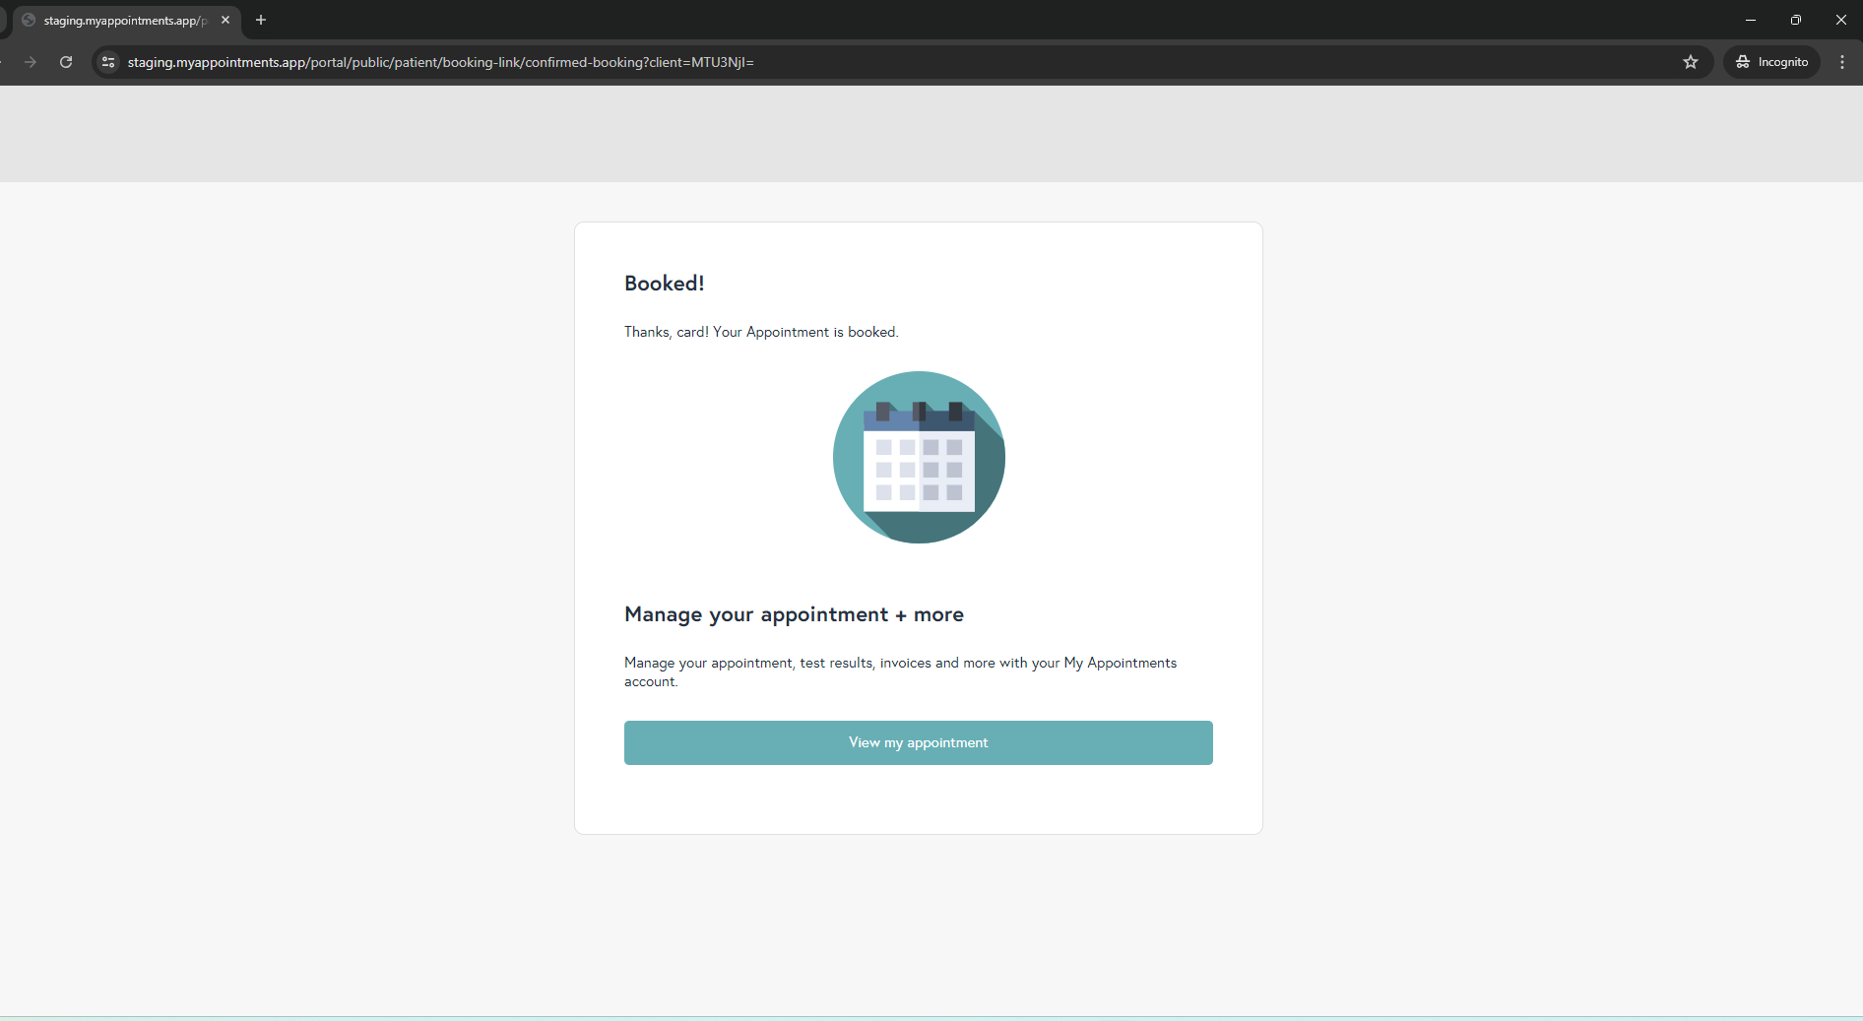
->confirmed booking text change done in staging - OK
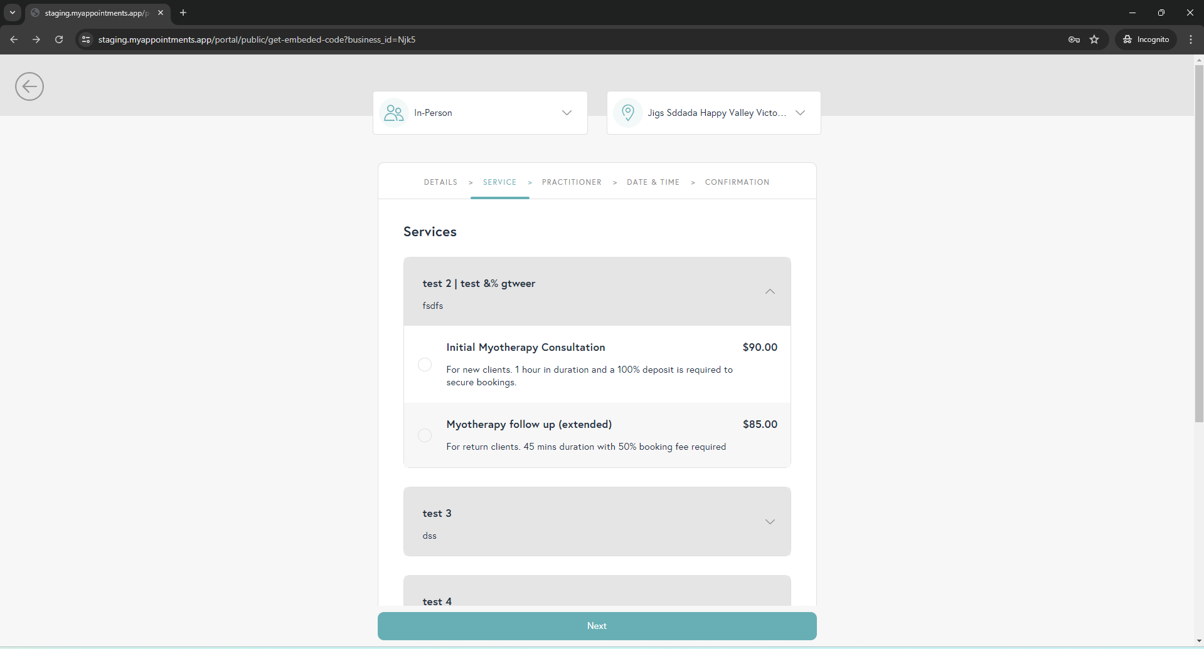
->show category issue in booking link done in staging - OK
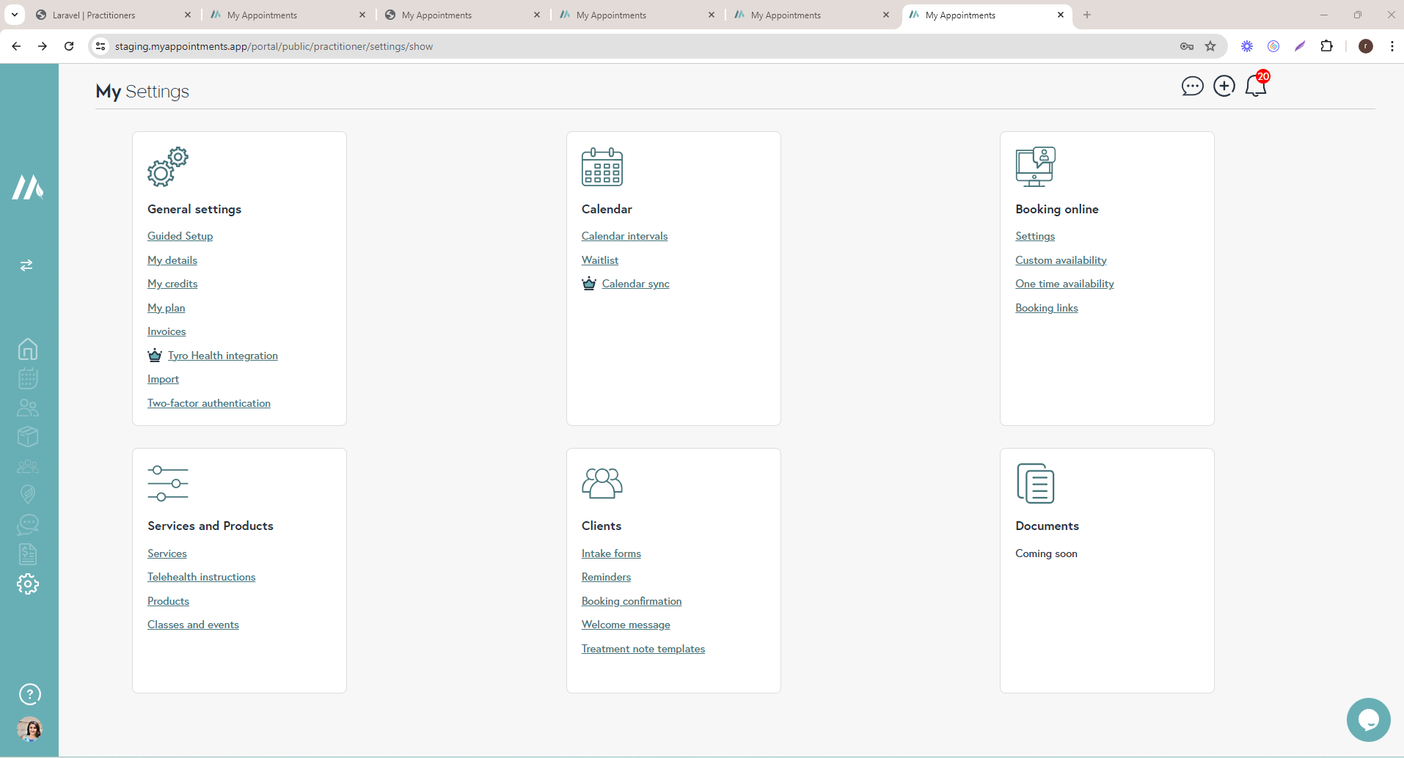
->premium account ficher on calendar sync and Tyro Health integration done in staging - OK
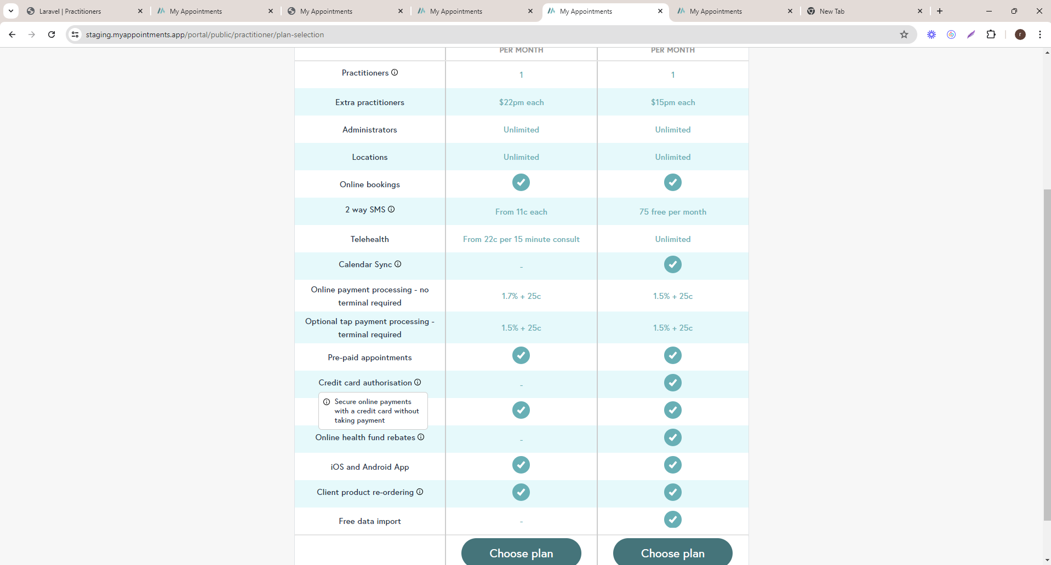
->select plan text change done in staging - OK
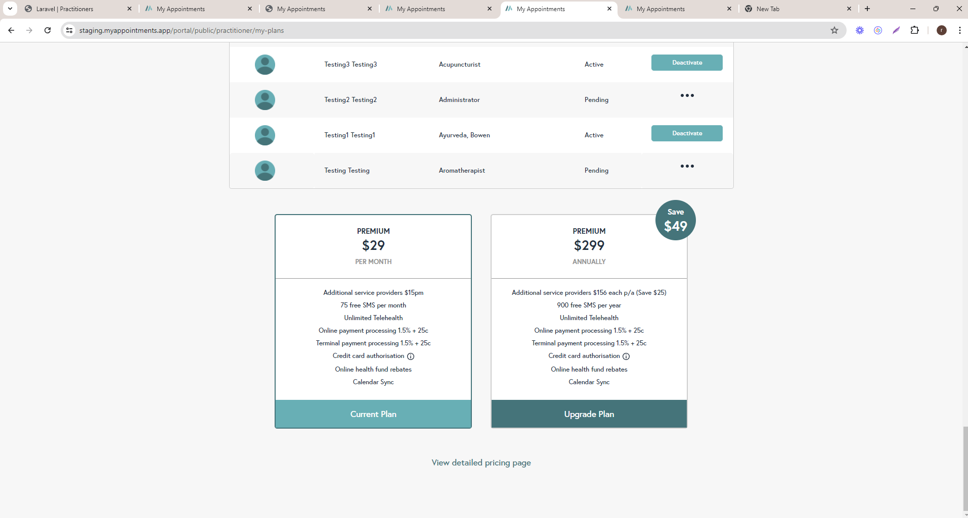
->my plan page text change done in staging
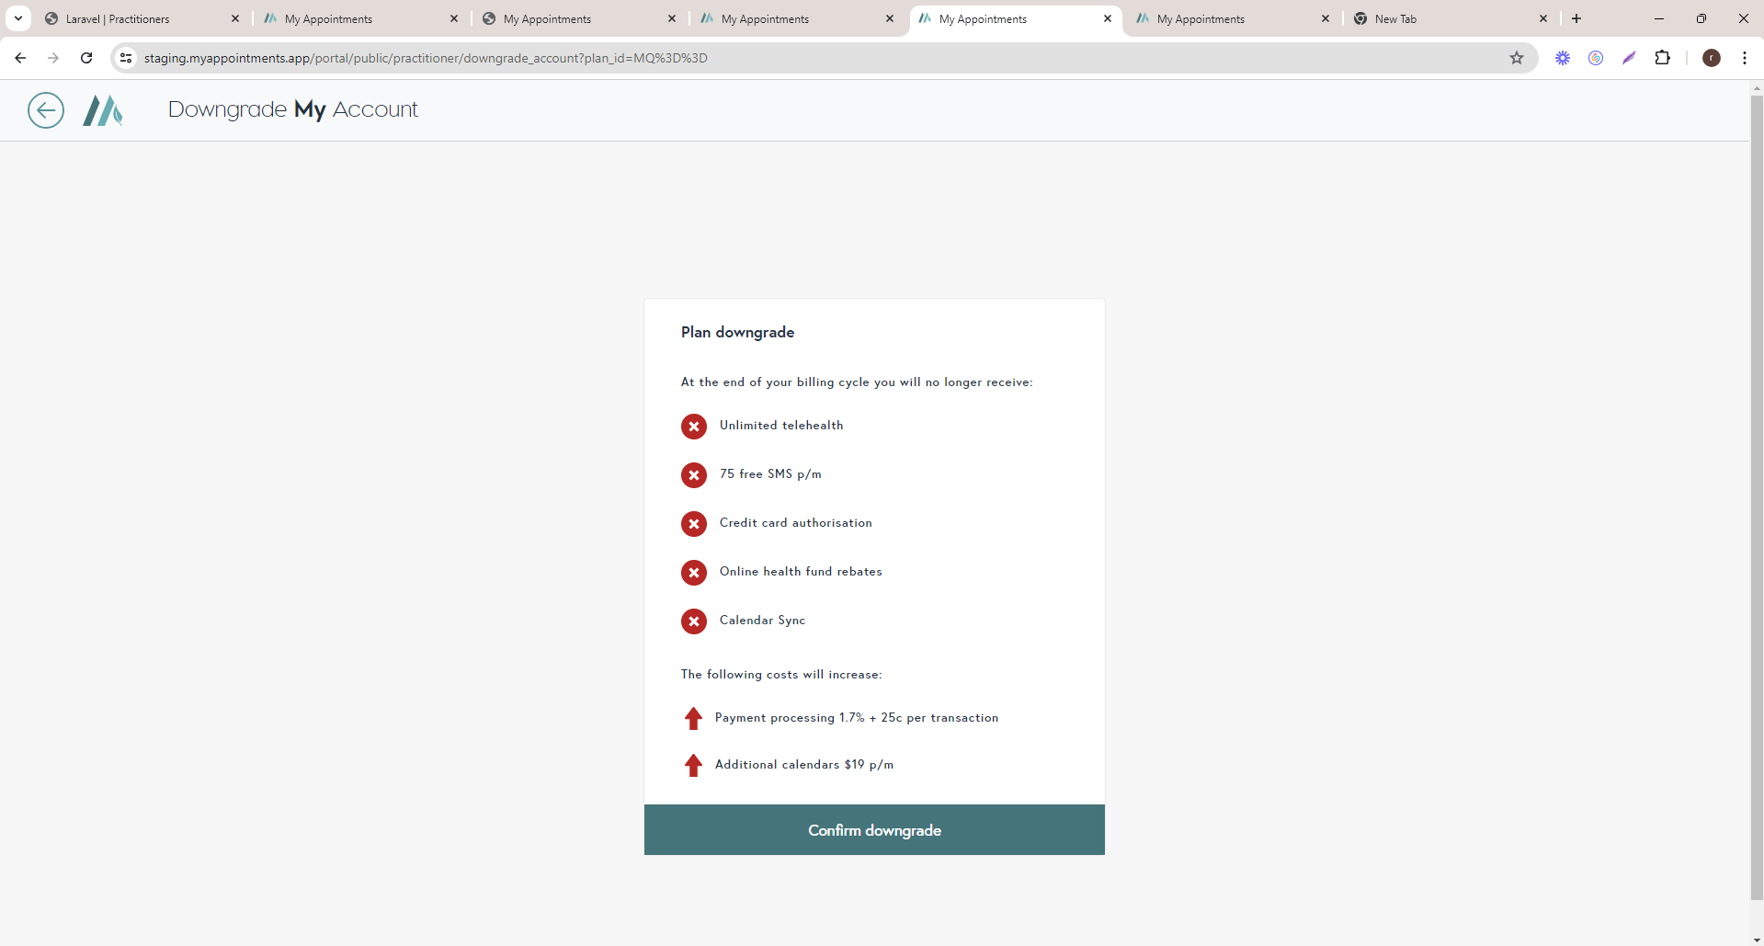->downgrade plan text change done in staging – ADDITIONAL CALENDARS SHOULD BE $22
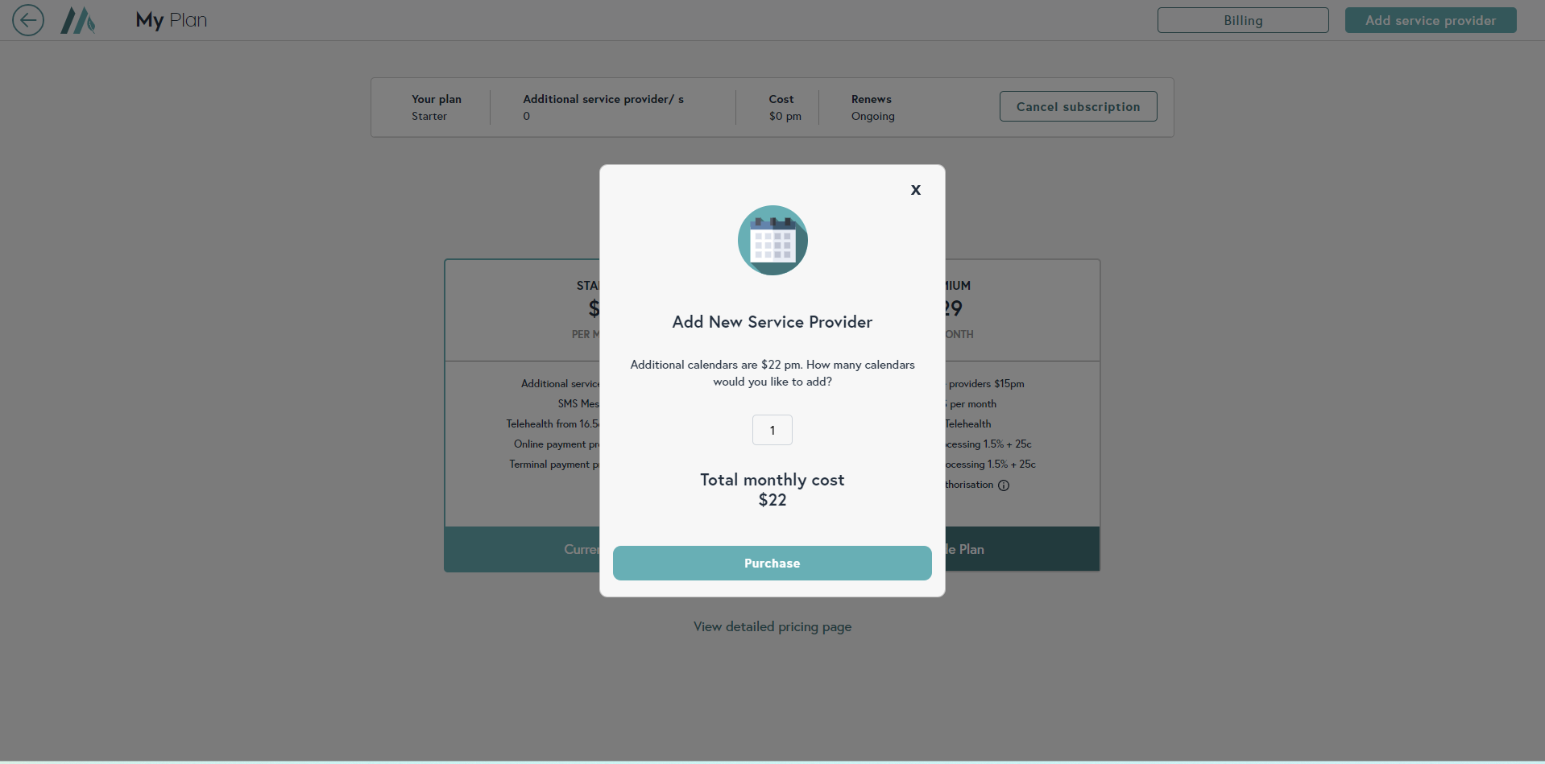
->change $0 plan calendar price done in staging - OK
->start vedio consult
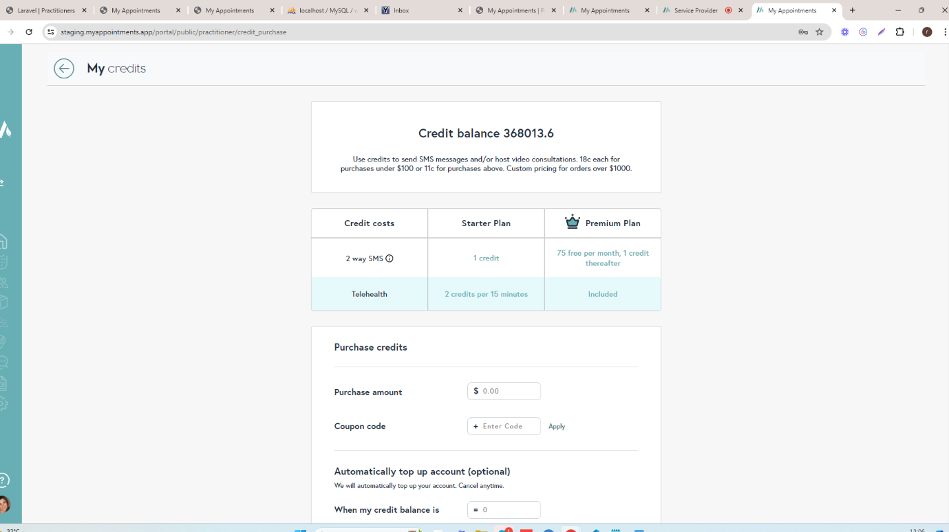
->already this credit in account
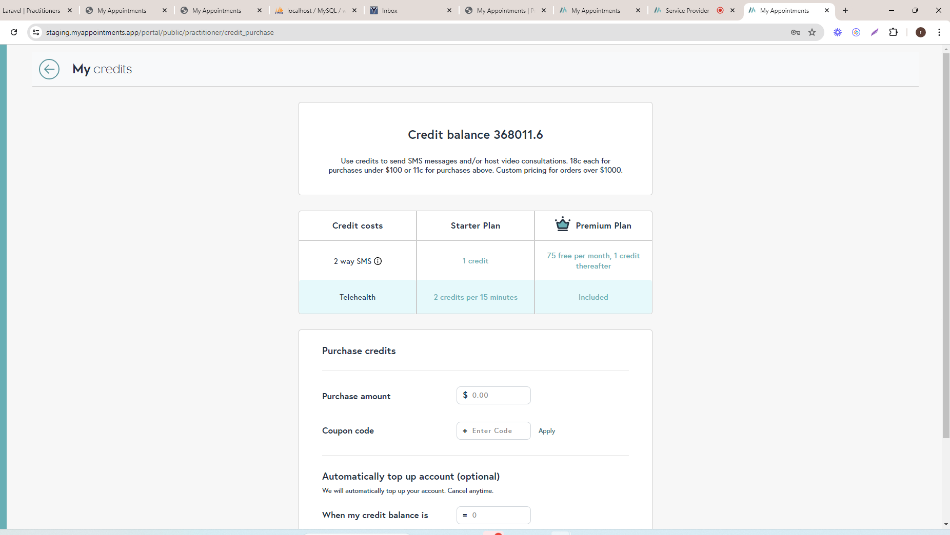
->then deduc 2 credits - OK
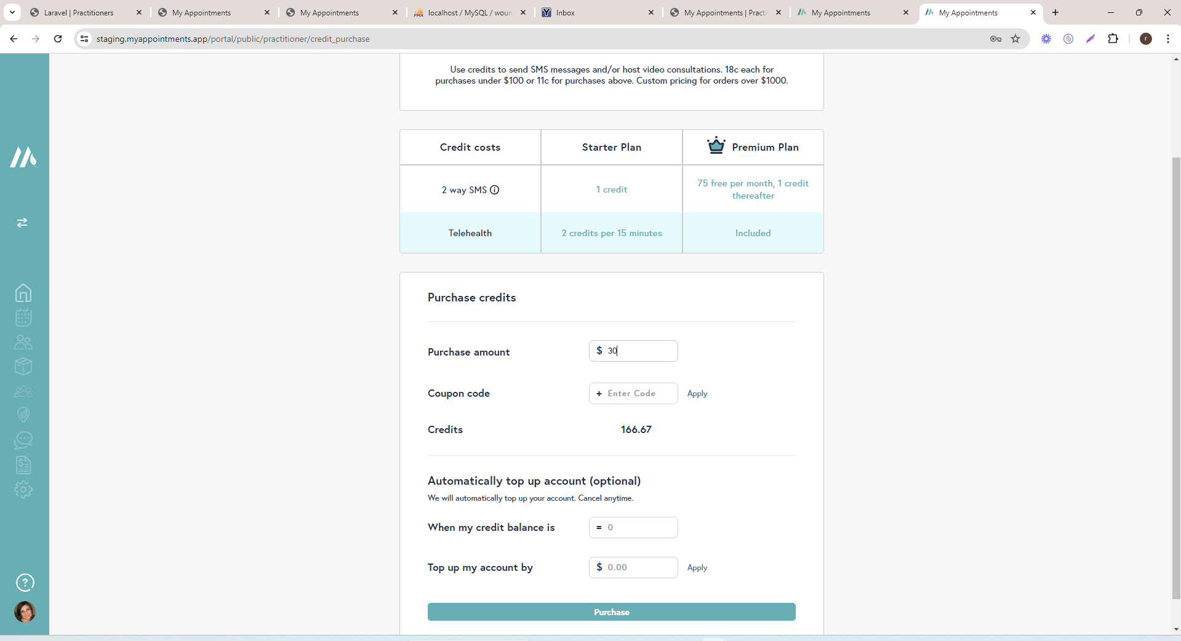
->change creadit calculation (18)

