

karen@ksnutrition.com.au
www.ksnutrition.com.au
0408320433
ABN 96 823 951 405

TREATMENT PLAN 1 – Initial Consult 9.6.23
SARAH GILES

Thank you for the opportunity to support you on your health journey.
As discussed in our consultation, treatment will take time as we unravel your conditions and any triggers for them. Your health is unique to you and therefore, your treatment plan/s are researched and written for your individual needs.
This treatment plan aims to:
- Initially, implement protocols to address eczema flares and symptoms.
- Support weight loss whilst implementing eczema protocols.
- Provide nervous system support through nutrition and lifestyle modifications.
- Systemic inflammation reduction.

Think of your body like a water tank. Every time it rains the tank fills up a bit more. If there is a downpour, the tank overflows. Your body can endure a lot of what you put into it, however, if you bombard it or continue filling it with things it doesn’t like over a long period of time, it will “overflow”. In people who are sensitive, this can happen sooner than others, but it happens to everybody at some point. It’s not just diet that fills the tank, but lifestyle, thoughts, lack of sleep, environment, toxins, relationships and so on all contribute to “filling” the tank. An overflowing tank can present in a multitude of ways. Mental health disruption, illness, skin conditions, digestive concerns, allergies and so on. An eczema “flare” may be an indication, or a low mental health period, fatigue, and illness.
We can help to empty our tank to keep it at a manageable level by having an early night, going on holiday, exercising, eating a nutritious meal, or laughing, for example. Though, in the long term this often doesn’t work with chronic illness or conditions taking over.
As you embark on this journey, keep the tank picture in the back of your mind (picture another vessel if that helps) and it might help you think twice before having or doing something that may overflow your tank.

FOOD AS MEDICINE
- DIET SUGGESTIONS
- 3 meals a day and 2 snacks. Learn to listen to your hunger cues. Initially, when you feel hungry, your body isn’t signaling for food but finalizing the digestion process of the last meal you ate. It’s good to have at least 4 hours between meals.

- To assist with inflammation reduction and begin weight loss I’d like you to look at the Mediterranean diet style of eating. There are some foods in this diet that can be triggering for some eczema sufferers, but at this stage we don’t know what is triggering you so if you get a flare we can look at what may have caused it.
Basically, I’d like you to focus on increasing fruit and vegetables, fibre/wholegrains, limit dairy, and increase the ‘good’ omega 3 fats through oily fish, olive oil, avocado, nuts and seeds. Eczema sufferers have been found to be low in these which can affect how the skin retains moisture.
I have added this link as a guide. It has a good diagram and some meal/snack ideas.
https://www.health.qld.gov.au/__data/assets/pdf_file/0032/946049/cardiac-meddiet.pdf

- Try to reduce sugar and alcohol for the next 1-2 weeks as these can increase the inflammation in the body and therefore, the skin. They also have a negative effect on mood and weight.

- Hydration – water, broths, clear soups, tea (herbal teas, green tea) all count towards your hydration goal. When you feel hungry, have a glass of water as often it can be a sign of dehydration rather than actual hunger.

LIFESTYLE
- Ensure you are eating mindfully. Sit up at the table, chew your food thoroughly and remove distractions like television. It is best to consume any drinks away from your food as this can dilute valuable digestive secretions and may affect nutrient absorption. Remain upright for 15-20 minutes after eating to aid peristalsis and the movement of food down the digestive tract. https://www.nutritionist-resource.org.uk/memberarticles/mindful-eating-a-tool-to-fix-your-digestive-problems

- Breathing technique to aid relaxation. Box breathing – sit quietly and upright. Try and breathe as deeply as possible. INHALE for 4 seconds, HOLD for 4 seconds, EXHALE for 4 seconds, HOLD for 4 seconds. Repeat as needed. Try and do this throughout your day. Sometimes we get home at the end of the day and realise we have been shallow breathing all day.
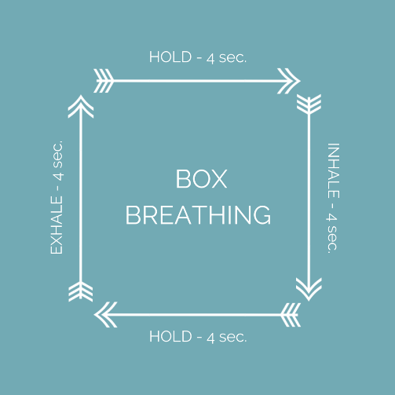

- Exercise – this is important for mood support and also to assist with weight loss. Beginning with some light weights will help to increase lean muscle which will increase your metabolism, helping to burn fat stores. Weights will also not induce too much sweating which will help with your skin. Wear breathable loose clothing to enable air flow.
- Be conscious of possible allergens/toxins. Hidden fragrances/additives in personal and laundry products, new furniture/carpet, dust mites etc.

PRESCRIPTION
I will add you to the Vital.ly platform with prescriptions for some practitioner-only supplements. These are optional but can support skin integrity and barrier dysfunction especially if your diet is low in certain nutrients.
Suggested at this stage: good quality EPA/DHA for skin integrity/suppress inflammatory response, Quercetin for inflammation reduction/antioxidant, Vitamin C for healing/collagen repair/antioxidant, and a probiotic strain, Lactobacillus rhamnosus GG has shown to help with hypersensitivity and genetically predisposed atopy.
You will receive an invitation to the platform where you can order your supplements and they will be mailed direct to your door. I offer these at a discounted rate.
In the future, there may be an opportunity for a personalized nutritional compound that I make myself.

PATHOLOGY

There are several functional medicine tests that can be done to further investigate the root cause of your symptoms. These are an extra cost to you as I am not eligible for Medicare rebates. If you have any results or reports from your GP (standard pathology etc), these are handy for me to look at as an underlying indication is often visible.

FOOD DIARY
Please return your food diary periodically to karen@ksnutrition.com.au so that I can analyse nutrient balance. This will prevent time loss in consultations.

MEAL PLANS
A 7 day meal plan and shopping list with recipes can be put together for you. Let me know.

Follow-up – 2 weeks. Book via website or email me your desired time.

Please don’t hesitate to contact me should you have any questions.

Karen x

