

karen@ksnutrition.com.au
www.ksnutrition.com.au
0408320433
ABN 96 823 951 405

TREATMENT PLAN 1 – Initial Consult 7.2.23
JILL SMITH

Thank you for the opportunity to support you on your health journey. I hope you feel rested after your holiday!
As discussed in our consultation, our plan of treatment involves addressing the immediate symptoms so that you begin to feel better initially, and then working on finding the root cause in future consultations.
This treatment plan aims to:
- Implement protocols to support symptomatic relief for chronic diarrhoea.
- Reduce transit time by slowing down motility of gastrointestinal tract through introduction of probiotics and nutritional support.
- Address inflammation through nutrition and lifestyle modifications.

PRESCRIPTION
Orthoplex White – Ultra GG Immune – 1 capsule daily. This is a particular Lactobacillus strain with a lot of research behind it for gastrointestinal conditions, especially diarrhea from a wide variety of causes.

MedLab ORS Biotic - make a weak solution with ½ scoop in 200ml water. If tolerated, increase to 1 scoop in 200ml water. Can be taken after each bowel movement.

PHGG (partially hydrolysed guar gum), psyllium powder etc – types of soluble fibre to add bulk to the stool and possibly slow motility of the digestive tract. Depending on the fibre used will vary the dosage. I will add some suggestions to your prescription in My Appointments.

These can be ordered through your My Appointments account and posted to your home. Supplements are optional but will enhance your treatment at this stage.

FOOD AS MEDICINE
- DIET SUGGESTIONS
- While ascertaining the cause of the diarrhoea, aim for small frequent meals/snacks rather than 3 larger meals. 5-6 times per day is good as smaller, easy to digest meals/snacks will give your digestive system a rest.
- Try to limit sugar, alcohol and caffeine for the next 1-2 weeks as these can alter the speed of transit time of digestion and fluid balance. This includes sugar alcohols like sorbitol and mannitol.
- Try to eat simply and “blandly” for a minimum of 3 to 5 days to relieve inflammation and rest the digestive tract. A suggestion is the “BRAT” diet – “bananas, rice, applesauce and toast”. A guide below taken from www.healthline.com. Plain pasta, crackers, toast, well cooked foods to reduce digestion effort. Bananas help to replace the potassium lost. Some plain scrambled egg, low acid foods, low fibre foods. After 3 days, if feeling ok, increase variety by including more soft, slow cooked foods like soups, poached chicken.

What you can eat on the BRAT diet – from Healthline.com
Some doctors specify that a bland diet is different from the BRAT diet. But most agree that you can eat more than just bananas, applesauce, rice, and toast on the BRAT diet. The key is to eat bland foods that are gentle on the stomach.
Other bland foods include:
- crackers
- cooked cereals, like oatmeal
- weak tea
- apple sauce
- broth
- boiled or baked potatoes
People should avoid foods that are “non bland” on this diet. They include:
- milk and dairy
- anything fried, greasy, fatty, or spicy
- proteins, such as steak, pork, salmon, and sardines
- raw veggies, including salad greens, carrot sticks, broccoli, and cauliflower
- acidic fruits, such as berries, grapes, oranges, lemons, and limes
- very hot or cold drinks
- alcohol, coffee, or other drinks containing caffeine
Summary: The BRAT diet consists of foods low in fiber that are gentle on the stomach, like bananas, rice, applesauce, toast, crackers and chicken broth. Non-bland foods should be avoided.

- Hydration – water, broth, tea (especially marshmallow root, chamomile, lemon/ginger), rehydration solution.
- Avoid cruciferous vegetables such as cabbage, broccoli, Brussels sprouts and legumes/beans that can increase gas in the intestines and colon.

LIFESTYLE
- Ensure you are eating mindfully. Sit up to the table, chew your food thoroughly and remove distractions like television. It is best to consume any drinks away from your food as this can dilute valuable digestive secretions and may affect nutrient absorption. Remain upright for 15-20 minutes after eating to aid peristalsis and the movement of food down the digestive tract. https://www.nutritionist-resource.org.uk/memberarticles/mindful-eating-a-tool-to-fix-your-digestive-problems
- Breathing technique to aid relaxation. Box breathing – sit quietly and upright. Try and breathe as deeply as possible. INHALE for 4 seconds, HOLD for 4 seconds, EXHALE for 4 seconds, HOLD for 4 seconds. Repeat as needed.
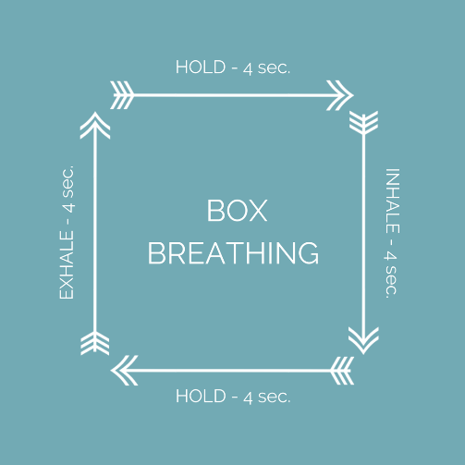

- Add some light walking and stretching into your day. Listen to your body and rest when needed. It may take some time to regain energy levels.
- REST – when needed.

PATHOLOGY

There are several tests that can be done to further investigate the root cause of your symptoms. These are an extra cost to you as I am not covered by Medicare, so if you have any results or reports from your colonoscopy/gastroscopy, recent bloods, stool tests etc would be a great help.
Suggested tests could include Complete Stool Analysis, Microbiome Mapping, and H-pylori breath test.

FOOD DIARY

Please return your food diary periodically to karen@ksnutrition.com.au so that I can analyse nutrient balance. This will prevent time loss in consultations.

MEAL PLANS
If required, I can devise a 7 day meal plan and shopping list.

Follow-up – 2 weeks. Book via website.

Please don’t hesitate to contact me should you have any questions.

Karen x

