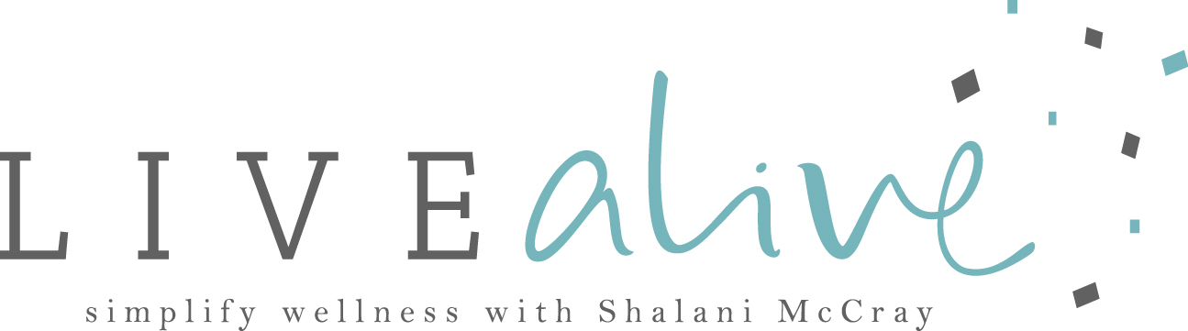

SEED CYCLING

PHASE 1

WHEN: Follicular phase of cycle.
Traditionally days 1-14 of your cycle or until ovulation.
*If no cycle or erratic cycle then on first day of the new moon

WHAT: 1tbs flax seeds + 1 tbs pumpkin seeds freshly ground

PHASE 2

WHEN: Luteal phase of cycle.
Traditionally days 15-28 of your cycle or until menses.
*If no cycle or erratic cycle then on the full moon

WHAT: 1tbs sesame seeds + 1 tbs sunflower seeds

*When your menstruation returns or becomes more regular then you can start following your own cycle.

For men:
1tbs combined flax + pumpkin on full moon
1tbs combined sesame + sunflower seeds on new moon
(it’s the opposite)

Seeds should be purchased raw and whole.
Grind them as required (a little coffee grinder works well for this).
You can do 2 days worth in advance however please refrigerate immediately after grinding.
Organic or spray free seeds are always preferred.
Ground seeds can be consumed on their own or in soups, smoothies, yoghurt, porridge or salads.

While some women can notice a difference within a week it usually takes up to 3 months

©livealivehealthcreation

