RECIPE
Nuts & seeds
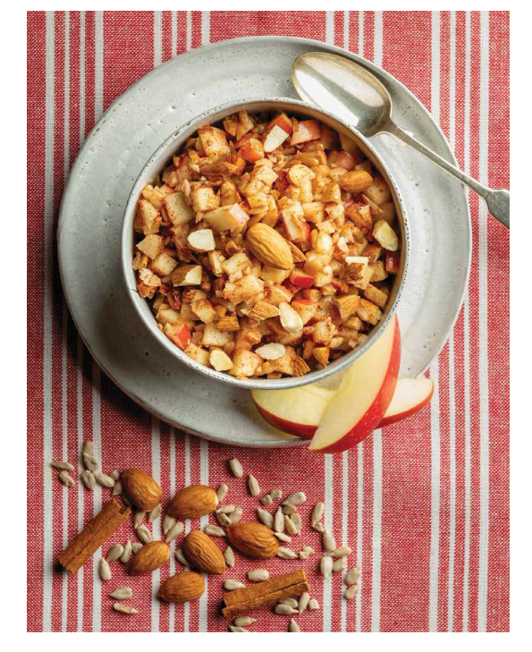Breakfast idea consisting of soaked nuts and seeds combined with chopped fruit (in this case, apple, but you can substitute pear or berries, or whatever fruit is on your personal plan.
I like it with Red Delicious, Granny Smith, Fuji or Royal Gala apples, but choose any tart apple you like to eat. Soaking the almonds and sunflower seeds makes them easier to digest, which increases the absorption of nutrients. Try this for breakfast using whole, raw almonds with the skins for added dietary fiber, vitamins, and minerals. This can be served cool after prepping the ingredients or baked in muffin cups and served warm

Ingredients
- 3 tbsp | 30 g almonds
- 2 tbsp | 20 g sunflower seeds
- 1 medium apple, cored and finely chopped
- ¼ tsp ground cinnamon

Preparation
- Put the almonds and sunflower seeds in a small bowl and cover with cool water.
- Cover the bowl and let the nuts and seeds soak overnight on the counter.
- In the morning, drain the nuts and seeds and finely chop them. Transfer to a small bowl and stir in the apple and cinnamon.

Tips
Warm Version: Preheat the oven to 400°F | 205°C. Line 4 cups of a standard muffin tin with paper liners. Spoon the mixture into the lined muffin cups and bake for 15 minutes,

TIP: You can pulse the almonds and sunflower seeds with the apple in a food processor, but take care not to over-chop.


