Date: 9/1/23

Dear Tully

Thanks for coming in today. Please find suggestions below

The focus is on to have a good varied diet when you are not competing to maximise muscle growth, repair and providing nutrients for health. Making sure you are having enough protein + veggies/fruit + wholegrain carbs.
When competing the focus is on switching to easier to digest, higher carb foods that will provide you with more instant energy (this is where it is ok to have white bread or things with a bit more sugar).

Meal Suggestions
Breakfast | - Overnight oats (recipe attached in Grab and Go Breakfast handout)  - Frittata Veggie Muffins (Grab and Go Breakfast handout) – if you have these, have 2 of the muffins and a piece of toast (if you feel you need it)  - Smoothie:  20 grams whey protein isolate powder  1 cup coconut water  1 frozen banana  1 cup mixed berries  1 tsp raw cacao powder  2 tsp maple syrup  1 medjool date  - Yoghurt with granola and fruit (Jordans low sugar granola or Carmen’s almond vanilla granola)  Vaalia probiotic natural (this actually has more protein than Jalna that I mentioned, so best to go with this) or Chobani plain Greek yoghurt  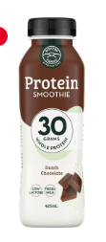  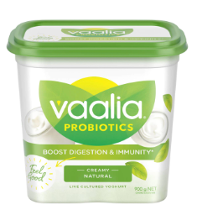  If you needed something super quick, then this is not a bad option:  Rokeby Farms Protein Smoothie (from Woolies)
Morning Tea | Same ideas as below for arvo
Lunch | Add kaleslaw to sandwich to bump up veg intake  Weigh chicken – want it to be around 130 – 150 grams cooked chicken. If it doesn’t add up to this much, then add a small tub yoghurt at lunchtime to boost your protein intake.
Afternoon Tea | Frittata veggie muffin (if you didn’t have at breakfast)  Carman’s peanut butter protein bar (x 1)  Hummus add veggie sticks or brown rice crackers  Piece fruit – Apple or banana  Small tub yoghurt
Dinner | Aim to have 130-150 grams cooked meat (as your protein) – chicken, red meat etc + ½ plate veggies/salad + wholegrain carb (eg brown rice, Vetta Smart Pasta …as this has more fibre and protein)

For when competing:
Fruit puree tube (like one below)
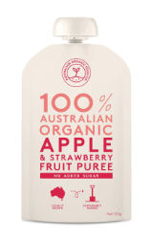
White bread sandwiches with banana and jam
Pumpkin seeds with salt (Connect Foods)
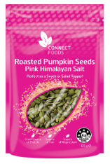
Banana
Medjool dates (instead of lollies to give you a sugar boost)
Granola bites (these ones from East Bali Cashews in Bali are quite good)
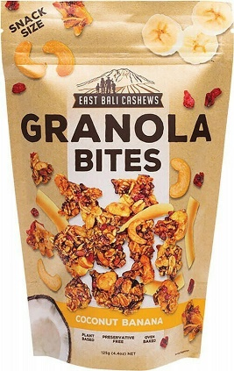

Bars – Tasti Made Simple Wholefood Bars (Forest Fruits) or Cliff Bar or All Natural Bakery Fruit & Oat Slice (these ones have more fat than the others so are better in a longer comp break as they will take longer to digest)
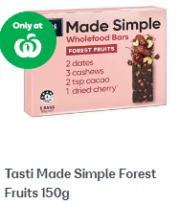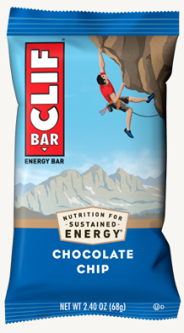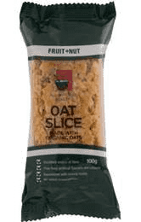

For longer breaks in competition have something a bit more substantial:
English muffins with egg, sauce and spinach…like these: https://www.frugalandthriving.com.au/bacon-and-egg-english-muffins/
Wrap with chicken and spinach and kaleslaw

For off days (between comps):
Refuel with protein (meat, chicken, yoghurt etc) and veggies + carbs

Let me know if you have any questions!

