Date: 1/3/23

Dear Sequoia,

Lovely to meet you today and thanks for trusting me to help you with your health.

Diet and lifestyle recommendations

- Balance your plate: Focus on increasing the protein and healthy fats in meals and reducing carbohydrate portions so that your insulin isn’t working as hard. By combining the 3 macronutrients (carb, protein and healthy fat) at main meals and snacks it helps to balance the blood sugars which is the overall aim. See graph below on how each macronutrient causes insulin to spike. Aim for your meal to look like the plate model picture below:
½ plate non starchy veg / salad (this is basically any veg except white potato and sweet potato)
¼ plate protein
1/8 – ¼ plate wholegrain carbs (best to keep this portion down and go for wholegrain options where possible) – brown rice, wholemeal pasta, sweet potato, etc
And some healthy fats (avocado, nuts, seeds, extra virgin olive oil, olives) 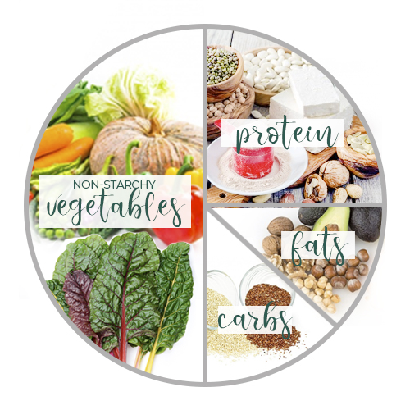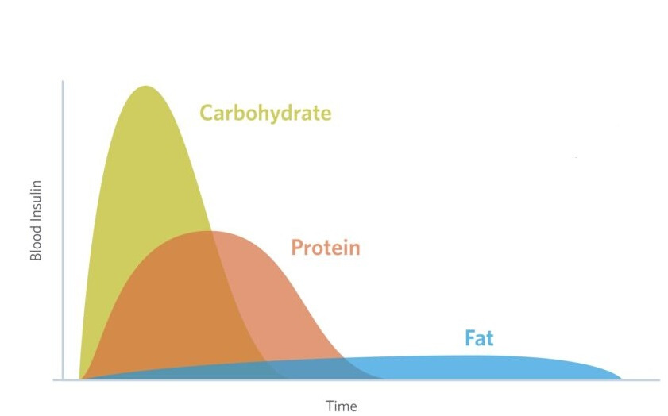
- Continue taking the metformin how you have currently been (in morning), and add in the Myo Sense as per instructions below.
- Continue to work on reducing the afternoon nap so you sleep better at night – a more consistent, earlier sleep will help with your overall mood, energy and weight goals.
- Aim to walk for 10 minutes (can be more) after your main meals to help use the glucose your body has just digested – the muscles will pull the glucose into them to be used (rather than if you sit after a meal and it stays in the bloodstream for longer).
- Try and eat in a calm / not stressed state to aid digestion – even taking some deep breaths before eating a meal, not eating in front of a screen.
- With the evening sweet craving, stop and ask yourself “am I hungry or is it habit”…write down 4 other things you could do for a break rather than using food (just has to be little things like a short movement break, listen to some fave music, etc to distract you from the food and train yourself to not be using food as a reward / boredom buster).
- Opt for lower carb alcohol options where possible – vodka/lime/soda a better choice than beer or Bundy.

Supplements

Product | How much… | When to take… | This supplement will help with…
Bioclinic Myo-Sense | 2 scoops in water  (ideally would be best to have one scoop morning & one in arvo/night but see what will work with your schedule best) | Once daily in the morning | Lowers insulin and glucose, helps utilise carbs more effectively, help with weight loss, assist improving anxiety/depression.

Meal Suggestions
Breakfast | 1 x wholegrain toast + 2 eggs (+ veg side eg mushrooms) – try and limit bacon due to the saturated fats.  On weekend, switch oat sachets to Carmans Almond Pecan Hazelnut sachets with 1-2 tablespoons of ground linseed/flaxseed on top (you will find these in the health food section of the supermarket)
Morning Tea | Switch snack to a piece of fruit + snack pack of nuts/seeds (any type of nut/seed pack is fine as long as not salted)  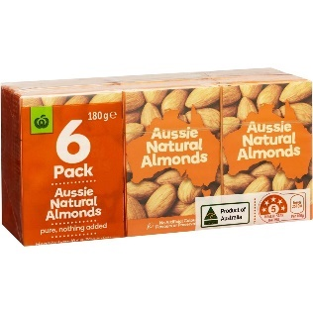
Lunch & Dinner | Aiming for your plate to always have a decent palm sized portion of protein (chicken, red meat, fish are highest in protein, then dairy or vegetarian sources like lentils, chickpeas) + ½ plate veggies + smaller amount carbs (pasta, rice, potato)

Next visit:
Wednesday 29th March at 2pm (40 min follow-up $85)

Let me know if you have any questions!

