Date: 16/10/2023

Dear Robyn,
Thanks for coming to see me I can’t wait to help you start feeling better – please find what we spoke about below. In the recommendations below I have focused on removing potential irritants which may be inflaming your gut and contributing to symptoms.
General diet recommendations:
- Reduce / eliminate some foods for until your next appointment in 4 weeks so we can review:
- Continue to eliminate alcohol
- Reduce coffee to one per day (even better if you can trial no coffee as this will be irritating the gut at the moment) – switch milk in coffee to Unsweetened Pureharvest Almond Milk – you’ll find this in both Woolies and Coles
- Remove dairy from the diet (cows milk, cheese, yoghurt etc)
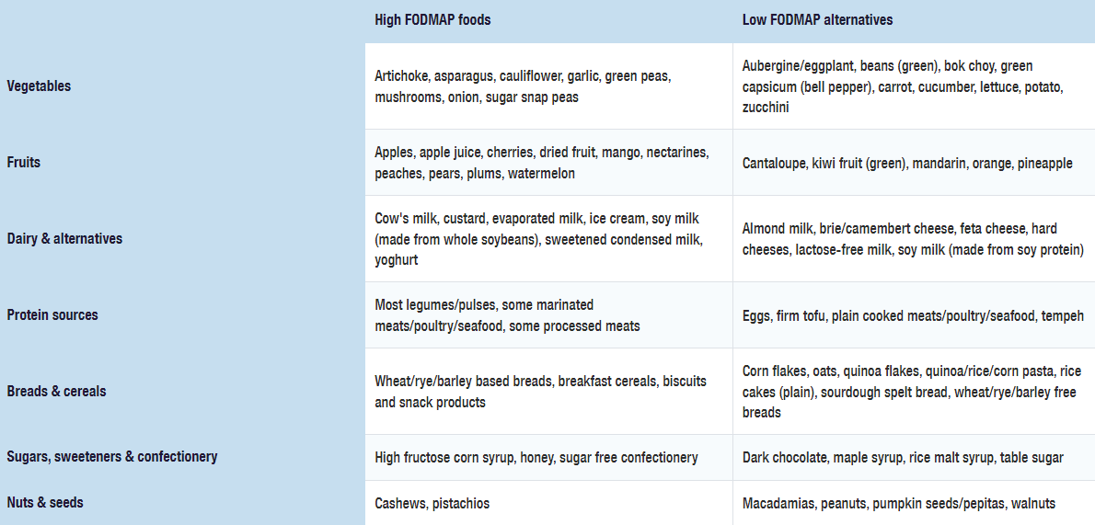
- Remove some foods high in FODMAPs (see table below for common culprits). Foods high in FODMAPs include garlic, leek, onion, grains and cereals (including wheat in crackers, cakes, bread) – switch to gluten free for now. If you need to replace garlic and onion for flavour, you can add garlic/onion flavoured olive oil – from Cobram estate in the supermarket.

- Remove red meat for the next 4 weeks (as this is much harder to digest) and stick to more easily digestible protein foods – fish and chicken, alongside cooked vegetables (in the low FODMAP list above). Keep white potato to a minimum due to the impact on your blood sugar.
- To help with sleep – focus on doing deep breathing (longer exhale) before bed or if you wake in the night. Sleepytime tea from the supermarket (1 hour before bed) can be useful.
- Reduce bread, rice, pasta, potatoes – these will all contribute to your blood sugars spiking.

Meal Suggestions
Breakfast | - Porridge – sprinkle with ground flaxseeds (you can buy these in the supermarket health food section) + blackberries or blueberries (rather than banana) + almond milk (as per above Pureharvest) – no honey  - 2 poached eggs + Zeally Bay Gluten Free Bread (you can buy this at Peachs)  - Frittata –Make sure the frittata doesn’t include any FODMAP foods.  https://www.monashfodmap.com/recipe/vegetable-frittata/  You could also try these carrot fritters (just make sure you use gluten free flour to replace the wheat flour): https://www.monashfodmap.com/recipe/carrot-fritters/
Lunch | - Slow cooked chicken soup (recipe attached) – don’t use garlic or onion though as these are high in FODMAPs (swap for garlic flavoured olive oil)  - Your chosen protein (fish or poached chicken) + steamed or roasted veggies.  Here is some instructions on how to poach chicken: https://www.recipetineats.com/poached-chicken/#wprm-recipe-container-42157  - You can find lots of low FODMAP recipes at the below website. Just make sure you use gluten free flour if the recipe needs flour:  https://www.monashfodmap.com/recipe/
Snack (if you need) | - Low FODMAP piece fruit: orange, pineapple, mandarin, kiwi.
Dinner | - Stick to your fish or chicken + low FODMAP vegetables from list above.  - Some other recipe ideas:  https://www.monashfodmap.com/recipe/herby-chicken-pork-meatballs-cranberry-sauce/

Next Appointment
Monday 13th November at 2.30pm (40 min appointment - $80)

I will review symptoms, and look at results from your other tests.
*Print the attached diet and symptom diary and complete this for 5 days prior to your appointment.
Let me know if you have any questions!

