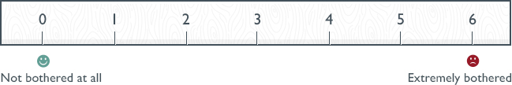
 | 0 | 1 | 2 | 3 | 4 | 5 | 6
Hot flushes or flashes | X
Night sweats |  | X
Sweating |  |  |  |  |  | X
Being dissatisfied with my personal life |  |  |  |  | X
Feeling anxious or nervous |  |  |  |  | X
Accomplishing less than I used to |  |  |  |  |  |  | X
Feeling depressed, down or blue |  |  |  |  |  |  | X
Being impatient with other people |  |  |  |  | X
Feelings of wanting to be alone |  |  |  |  | X
Flatulence (wind) or gas pains |  | X
Aching in muscles and joints |  |  | X
Feeling tired or worn out |  |  |  |  |  |  | X
Difficulty sleeping |  |  |  |  | X
Aches in the back of neck or head | X
Decrease in physical strength |  |  |  |  |  | X
Decrease in stamina |  |  |  |  |  | X
Feeling a lack of energy |  |  |  |  |  |  | X
Drying skin | X
Weight gain |  |  |  |  |  |  | X
Increased facial hair |  |  |  |  | X
Changes in appearance, texture or tone of your skin |  | X
Feeling bloated |  | X

