1.If you see a bug on the site and developer says it works for him, what are thing to check why it’s not working for you?

What would you test?
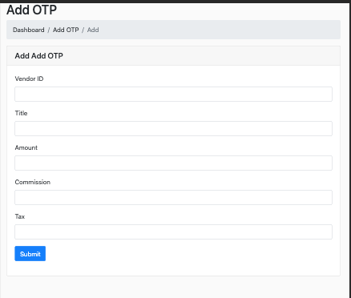

What is wrong with the black popup on this page? I want to see how detail oriented you are. This page is supposed to add a fashion post. This app is a fashion discovery app for people to sell used clothing.
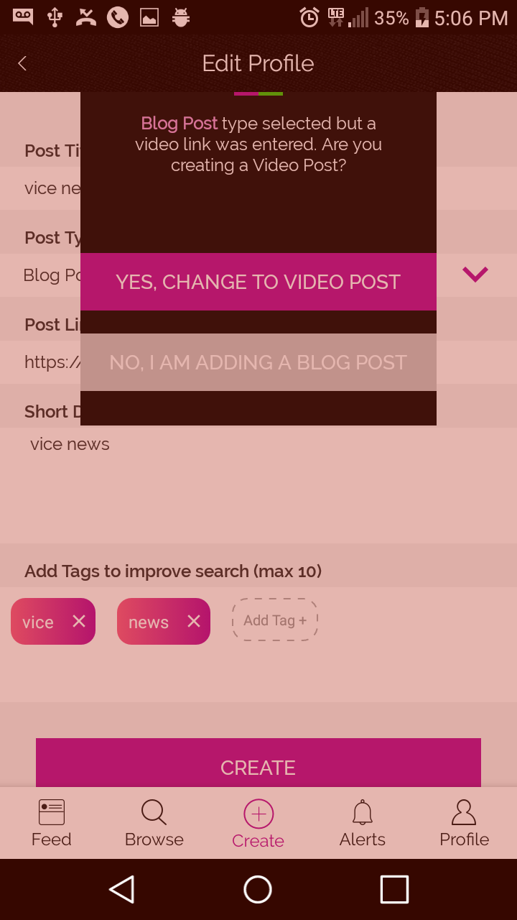

What is wrong with the cards on this page? Pay attention to the UI. Look closely. This app sells used clothing and jewelry. Notice the dimensions.
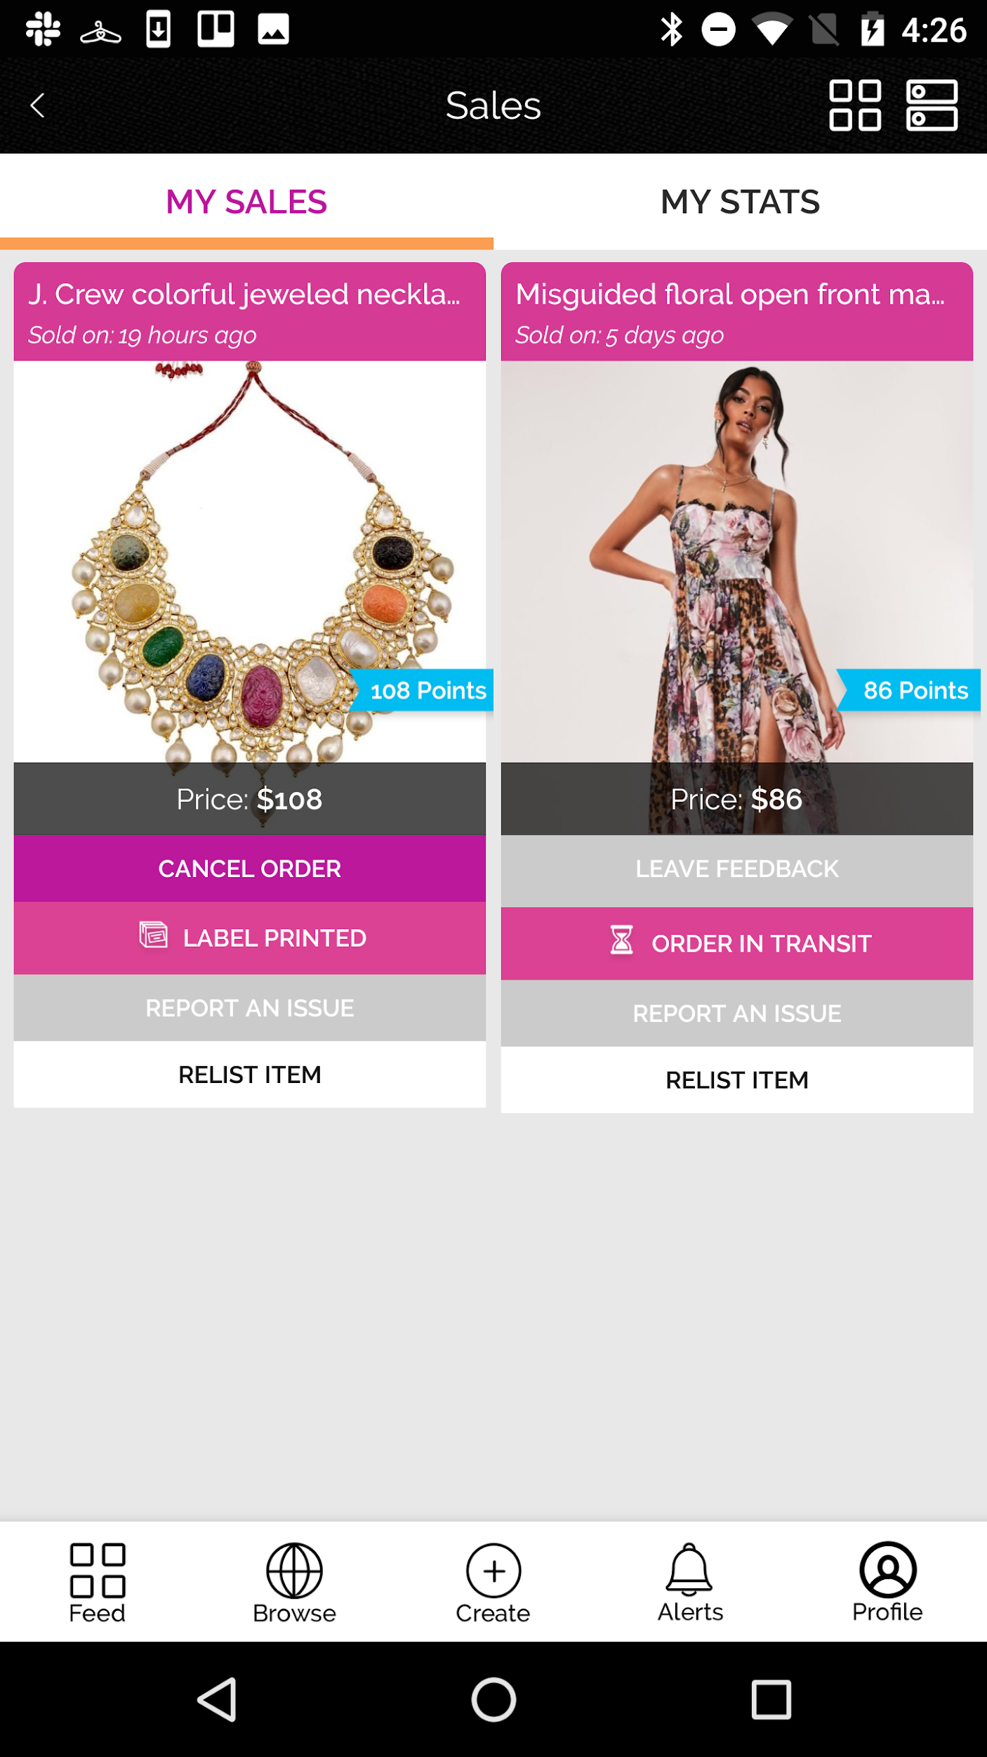

What’s wrong with this page? Pretend you are a USA seller. You are selling this item
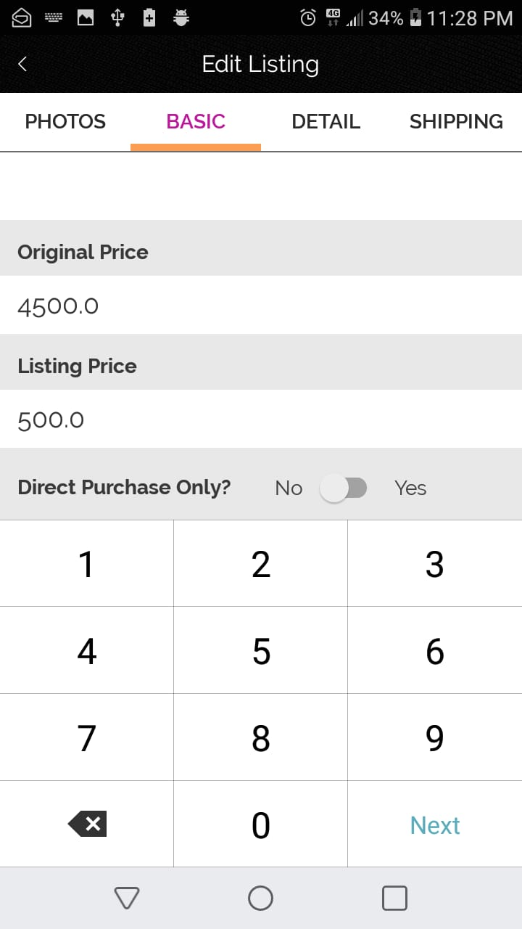

What’s wrong with this page. Pretend your a USA Seller. I want you to look carefully.
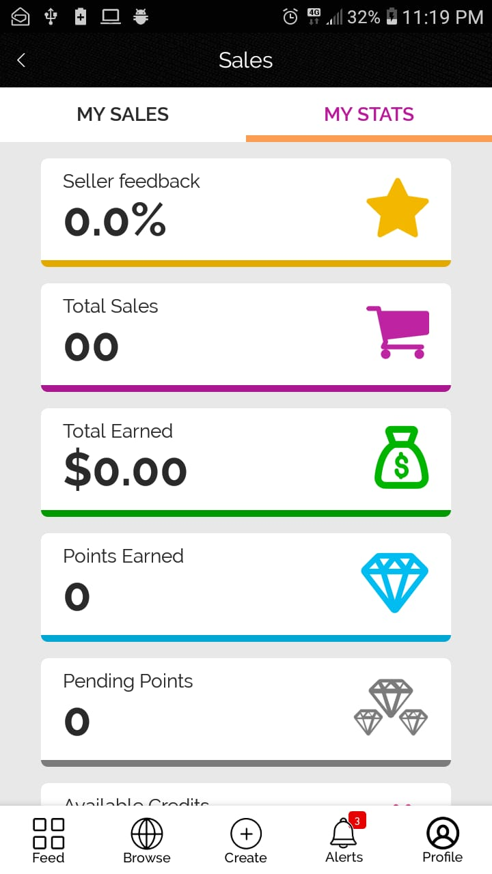

What’s wrong on this page. What realistic for a USA customer.

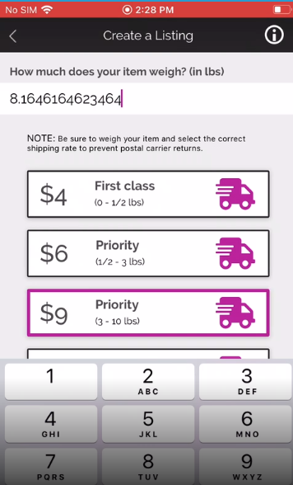

What the issue here
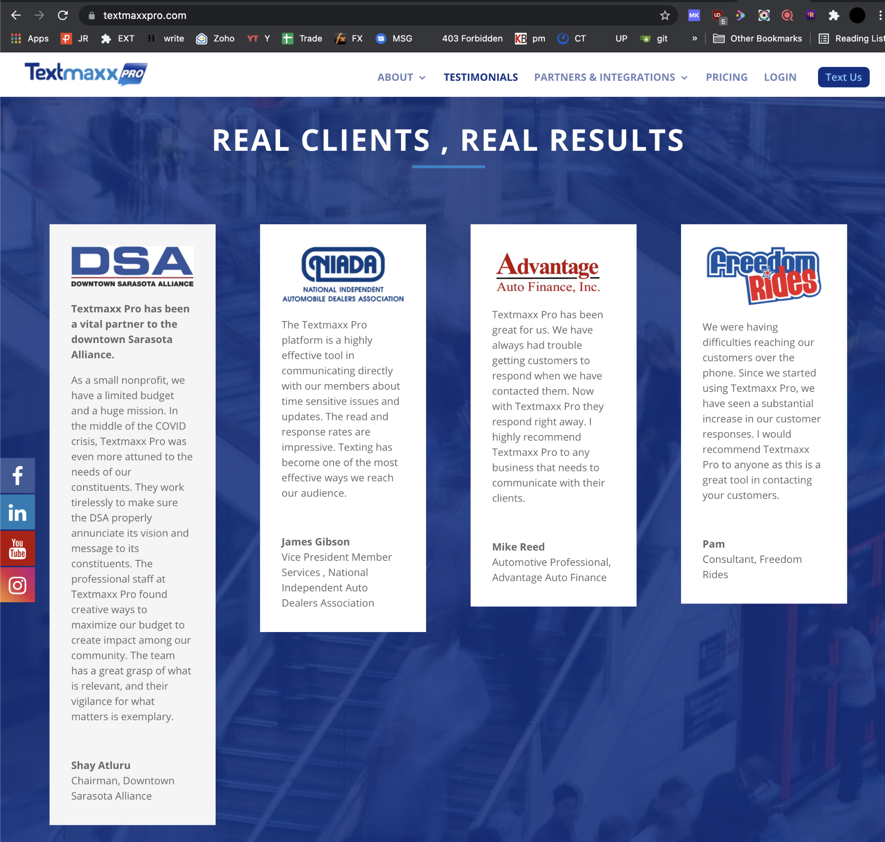

What the issue here. Pay close attention to images
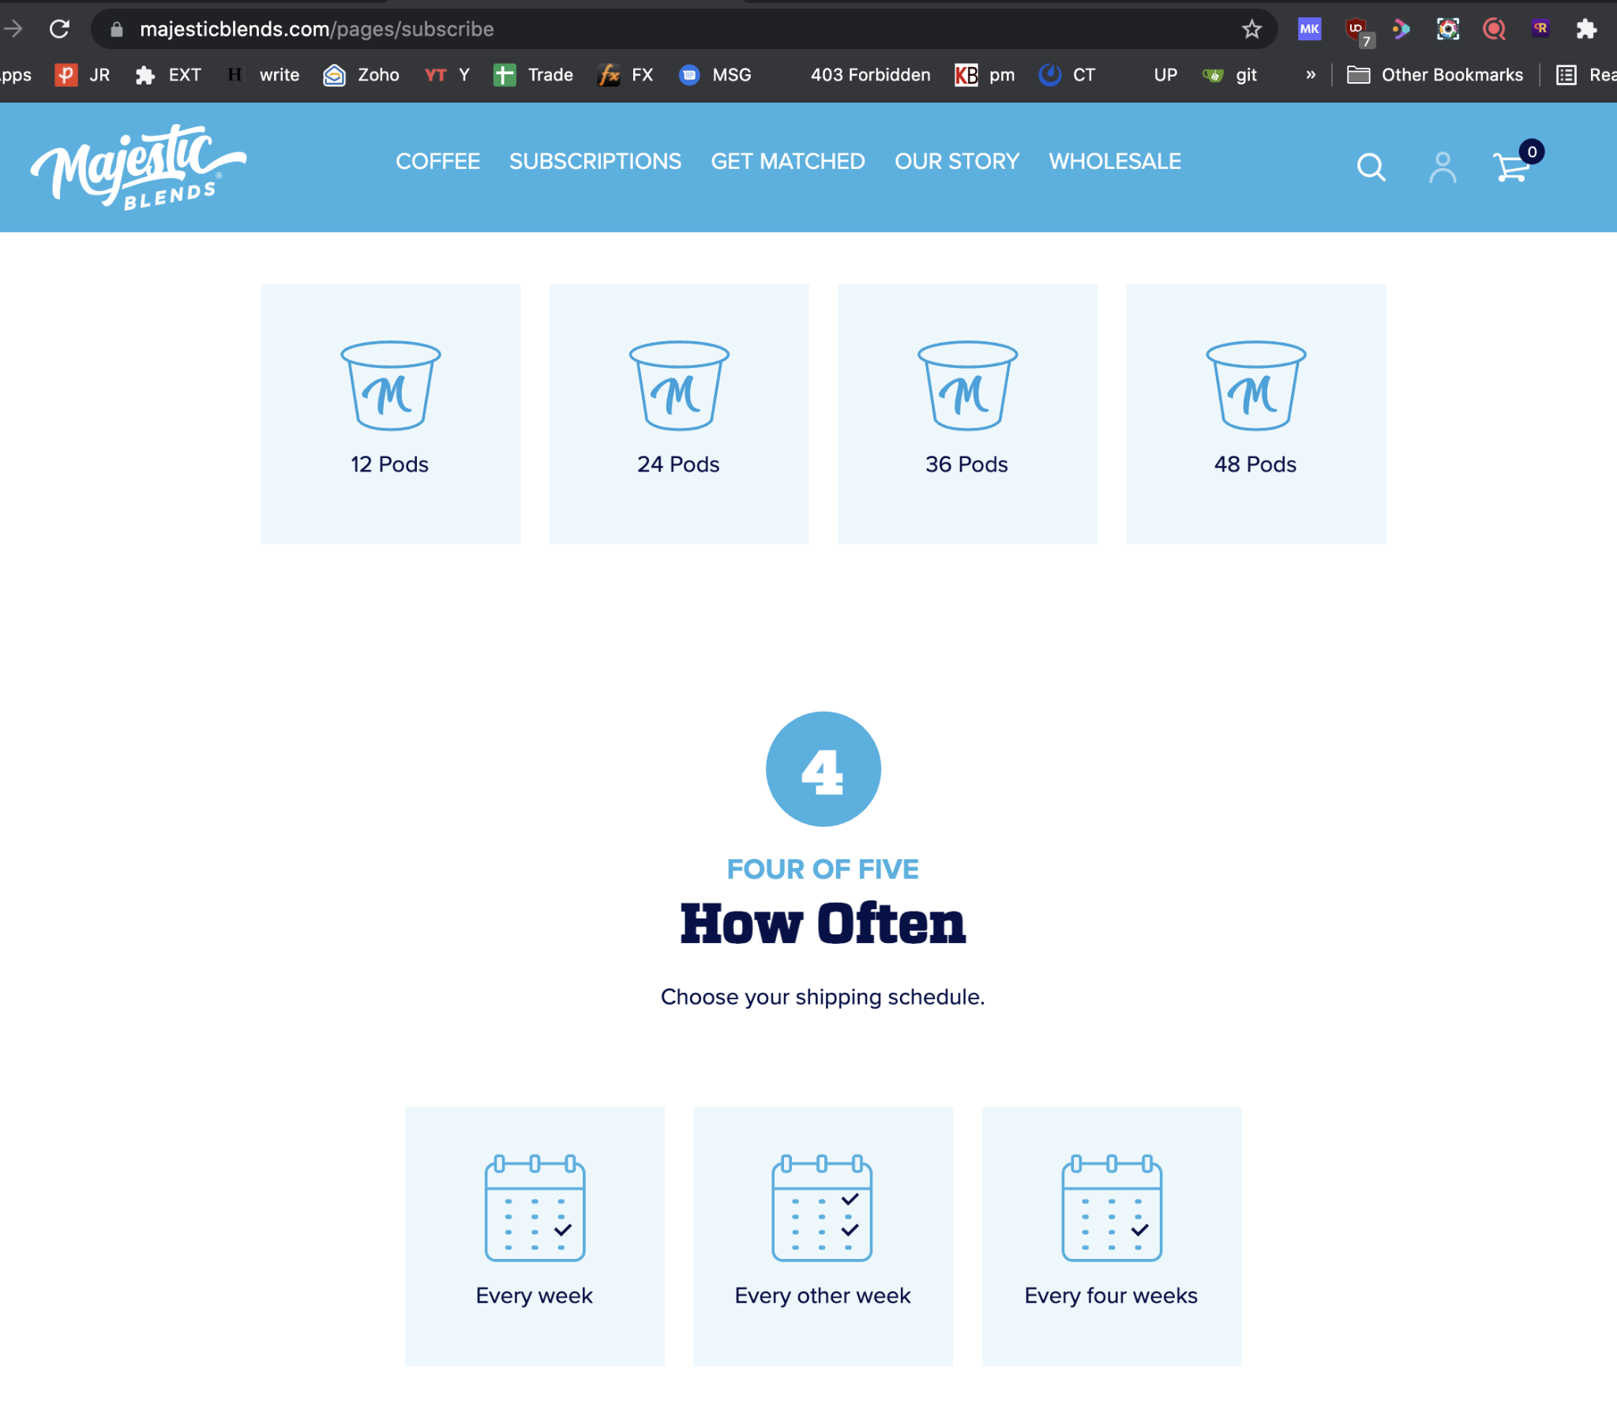

Identify the words spelt wrong
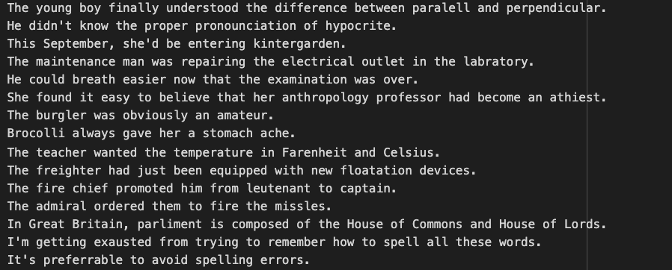

What should you test and look for?

