Additional Health Related Information:
I highlighted anything that was abnormal in RED, everything else was typical based on the reference ranges that were provided and/or it was not noted.

- 11/8/2025: Blood tests starting with REI:
- FSH:18.0
- E2:< 20
- AMH: 0.22 – noted to be typical, but I know it is NOT
- TSH: 1.37
- Vit D (25-O): 68.1
- 12/9/24: Progesterone: 4.0
- 1/18/2025:Estradiol (E2) – Had a cyst
- 1/27/2025: Progesterone: 10.1
- 1/29/2025:
  - Cytology PAP: Negative for intraepithelial lesion or malignancy- Normal
- 3/18/2025:
  - Rheumatoid Factor: < 10
  - ANA: 1:80 Speckled
  - AMH: 0.29 (ref range: 0.18-5.68- is typical..BUT I KNOW ITS NOT! LOL)
  - C Reactive Protein: 0.06
  - SED Rate: 14
  - Vitamin B12: 559
  - TSH with Free T4 Reflex: 1.82
  - Lipid Profile
    - Cholesterol: 150
    - Triglycerides: 58
    - HDL: 57
    - LDL: 95
    - VLDL: 11.6
    - Non HDL Cholesterol: 93
  - 25 OH Vit D (D2+D3): 48
  - Comprehensive Metabolic Panel
    - Sodium: 137
    - Potassium: 4
    - Chloride: 104
    - Glucose: 84
    - Blood Urea Nitrogen:16
    - Creatinine: 0.79
    - Calcium: 9.2
    - Total Protein: 7.1
    - Total Bilirubin: 1.1
    - Albumin: 4.5
    - Alk Phosphatase: 41
    - AST:20
    - ALT:15
    - CO2: 24
    - Anion Gap: 9
    - Glomerular Filtration Rate: >60
  - CBC
    - WBC: 6
    - RBC:4.44
    - Hemoglobin: 14.5
    - Hematocrit: 41.4
    - MCV: 93.2
    - MCHC: 35
    - RDW:13/1
    - Platelt Count: 212
    - MPV: 9.2

- 3/21/2025
  - Calprotectin, FECAL: <5
  - Centromere Antibodies: <0.2
  - Electrophoresis- Serum Protein- ABNORMAL
    - Total Protein: 6.8
    - Albumin%: 63.2
    - Alpha 1%: LOW 3.4
    - Alpha 2%: LOW 8/5
    - Beta: 11.3
    - Gamma% 13.6
  - SCL 70 Antibodies: <0.2
  - Anti Smith Anti RNP AB: <0.2
  - Anti SSA ANTI SSB AB: <0.2
  - JO 1 Antibodies: <0.2
  - ANTI-DNA< 10
  - C4 Completement 4: 26.6
  - C3 Complement 3: 111.3
  - CCP IGG Antobody: <0.5
- 4/3/2025- Rheumatologist
  - Hex Lupus Anticoagulant: Negative
  - Dilute Russell Viper Venom: 0.9
  - Beta 2 Glycoprotein 1 AB, IGM: 0.8
  - Beta 2 Glycoprotein 1 AB, IGG: <1.4
  - Cardiolipin iGG: <1.6
  - Cardiolipin IGM: 0.6

  - Urine
    - Urine Protein : <4
    - Urine Creatinine : 66
    - Protein/CR Ratio : no Value
    - Urine Analysis DipStick
      - Turbidity: ABNORMAL: +1
      - Specific Gravity- 1/011
      - Ph: 7.0
      - Protein, Billirubin, glucosa, ketones, blood: Negative
- 5/10/2025
  - SCL 70 Antibodies: <0.2
  - JO 1 Antibodies: <0.2
  - ANTI-DNA: <10
  - C4 Completement 4: 28.6
  - C3 Complement 3: 144.6
  - CCP IGG Antobody
  - Centromere Antibodies: <0.2
  - Anti Smith Anti RNP AB: <0.2
  - Anti SSA ANTI SSB AB: <0.2
  - Anti Smith Anti RNP AB: <0.2
  - Anti SSA ANTI SSB AB: <0.2
  - ANA : 1 :160 Speckled ABNORMAL
- 5/27/2025
  - Leptin: ABNORMAL: 15.6 HIGH
  - CMV AB IGG & IGM: Negative
  - Homocysteine: 5 (Ref Range: 5-15)
  - Iron+Binding Capacity +% SAT+Ferritin- ABNORMAL
    - Iron: 87
    - Iron Binding-TIBC: 346
    - % Saturation: 25-LOW
    - Transferrin: 232
    - Ferritin: 97
  - Anti-Thyroperoxidase (Microsomal) AB: 12
  - Cortisol-AM (Blood): 8.3
  - Progesterone: 7.9
- Uterine Biopsy- 5/28/2025 (Below and EMMA/ALICE results are separate and will send as an attachment)
  - 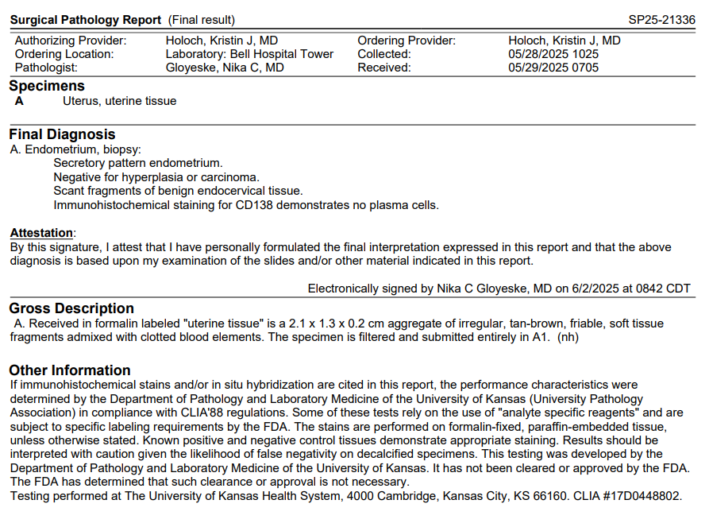
- 6/9/2025-(was in the early stages of pregnancy based on LMP)
  - Cortisol Free, Urine (24 hour collection)
    - Total Volume: 2950
    - Cortisol Urine per volume: 8.32
    - Cortisol Urine Free Ratio to CRT: 13/42
    - Cortisol Urine Free per 24H: 24.5
    - Creatinine, UR: 62
    - Creatinine, Urine per 24H: 1,829- HIGH
  - Insulin: 4.9
  - Glucose Fasting: 89
  - Hemoglobin A1C: 4.7
- 6/10/2025: Cortisol, Random (Blood- after I returned the urine) - was in the early stages of pregnancy based on LMP: 12.6- Typical
- 6/13/2025:
  - Beta-HCG: 271
  - Estradiol: 140.4
  - Progesterone: 11 (took supplements after this day of progesterone vaginally)
- 6/19/2025: was in the early stages of pregnancy based on LMP- Had an ultrasound this day and blood tests, pregnancy was not viable-Scheduled appointment for later in the week to have one more data point before DNA (was going on vacation after work on this day)
  - Ultrasound: Biometriy- 3.1 mm, G. Age: 4w4d
    - 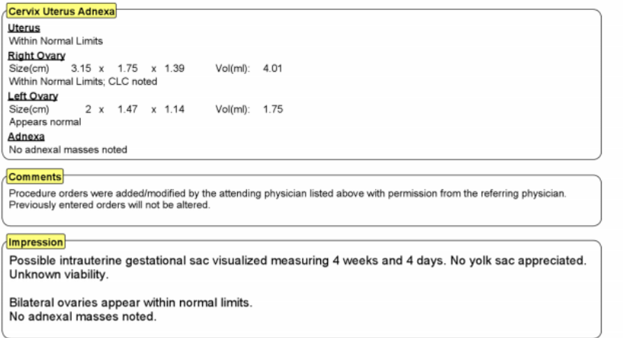
  - Hemoglobin A1C: 5.1
  - CBC- all typical
    - WBC: 5.9
    - RBC: 4.49
    - Hemoglobin: 14.4
    - MCV: 93.2
    - MCH: 32.1
    - RDW: 12.8
    - Platelet Count: 208
    - MPV: 9/4

  - Beta HCG: 336
  - Progesterone: 16
  - Estradiol:52.7
- 6/22/2025- in the Hospital-was in the early stages of pregnancy based on LMP- Had an ultrasound this day and blood tests, pregnancy was not viable- started to miscarry naturally
  - Ultrasound Results:
    - 1. No intrauterine gestational sac is visualized.
    - 2. Anterior lower uterine segment C-section scar with ill-defined hypoechogenicity of the surrounding myometrium, possible endometriosis at the scar. No increased blood flow in this region and cesarean section ectopic pregnancy is considered less likely. Recommend obstetric consultation as well as trending beta-hCG and repeat pelvic ultrasound as indicated.
    - 3. No adnexal mass.
  - BETA-HCG: 232- HIGH
  - TSH with Free T4 Reflex: 4.03
  - Comprehensive Metabolic Panel- all normal except calcium
    - Sodium: 137
    - Potassium: 3.6
    - Chloride: 107
    - Glucose: 93
    - Bloor Urea Nitrogen: 15
    - Creatinine: .87
    - Calcium: 8.4 LOW
    - Total Protein: 6.4
    - Total Bilirubin: 0.3
    - Albumin: 4.4
    - Alk Phosphates: 43
    - AST: 14
    - ALT: 9
    - CO2: 22
    - Anion Gap: 8
    - Glomerular Filtration Rate: > 60
  - CBC and DIFF- Everything normal except for RBC
    - WBC: 7.9
    - RBC: 3.99 LOW
    - Hemoglobin: 13
    - Hemocrit: 37.5
    - MCV: 94
    - MCH: 32.5
    - MCHC: 34.6
    - RDW: 13
    - Platelet Count: 194
    - MVP: 8.8
    - Meutrophils: 53.6
    - Lymphocytes: 36.2
    - Monocytes: 7.0
    - Eosinophils: 2.1
    - Basophils: 1.1
    - Absolute Neutrophl Count: 4.20
    - Absolute Lymph Count: 2.90
    - Absolute Monocyte Count: .20
    - Absolute Bsaphil Count: .10
    - Monocyte Distribution Width: 17.4
  - Urinanalysis
    - Turbidity: +1 ABNORMAL
    - Specific Gravity- Urine: 1/035 HIGH
    - Ph: 5.0
    - Protein: ABNORMAL: +2
    - Glucone: Negative
    - Ketones: Trace- ABNORMAL
    - Bilirubin: Negative
    - Blood, UA- ABNORMAL +3
    - Urobilinogen, UA- Normal
    - Nitrate: Negative
    - Leukocytes, UA Negative
      - Urinanalysis Microscope reflex to culture
        - RBC: Packed- ABNORMAL
        - Mucous, UA: ABNORMAL +2
        - Calcium Oxalate Crystals- Few- ABNORMAL
          - Everything else was normal
  - Renal and Bladder Ultrasound because I had creatinine elevation/protein in my urine on 6/9 and 6/22
- 6/27/2025- Follow up from miscarriage
  - Beta HCG: 13 HIGH
  - Ultrasound
    - 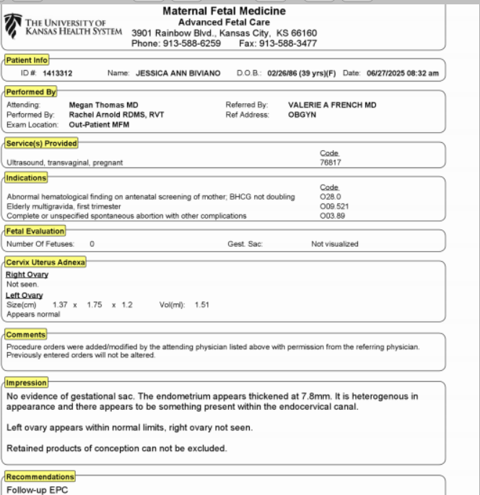
  - Rheumatologist appointment as a follow up/second opinion- completed 5 days after miscarraige
    - Miscellaneous Lab Test
    - Cardiolipn AB IGG/GM
      - IGG: < 1.6
      - IGM: 0.5
    - Beta 2 Glycoprotein AB, IGG: < 1.4
    - Beta 2 Glycoprotein 1 AB, IGM: 0.6
    - Dilute Russell Viper Venom: 0.9
    - Hex Lupus Anticoagulant: Negative
    - Thyrogobulin AB: 16
    - MIscellaneaous Lab test
    - Anti SSA Anti SSB AB: : <0.2
    - C3 (Complement 3): 125.5
    - C4 (Complement 4): 26.7
    - Anti-Nuclear Antigen: Below 80
    - Anti-DNA: <10
    - Anti Smith (SM) Anti RNP AB- <0.2
    - JO 1 Antibodies: : <0.2
    - Centromere Antibodies: <0.2
    - SCL 70 AB: : <0.2
- 7/24/2025 (Started Birth Control after the blood tests- ½ a BC pill at night)
  - FSH: 18.5
  - LH: 10.2
  - Progesterone: 0.7
  - Estradiol: < 15
  - Leptin (Rechecked no pregnant): 14.1 (.5-15.2= AVG)
  - Ultrasound: see ultrasound attachment
- 7/31/2025 (Continue BC pills until 8/5 and repeat ultrasound and bloodwork)
  - Prolactin: 5.6 (Normal Range: 3.3-26.7)
  - FSH: 15
  - LH: 14.6
  - Beta HCG: <1
  - Progesterone: .5
  - Estradiol: 61
  - See ultrasound attachment

