Dear Dr Neil
Thank you for seeing me. I have been struggling immensely since I received 2 shots of the Pfizer vaccine in 2021. I have seen a number of specialists over the past 3 years, with no real success.
I had a bad recent flare up of chest pain. With this latest visit to the cardiologist, my ECHO had apparently deteriorated and there were some signs of constriction – yet the treatment advised was the same as day one (3 years ago): NSAIDs and colchicine. She talked about possibly needing a surgical release of the pericardium in the future.
I am concerned that I’m not being ‘treated’ to prevent to deterioration. I have seen others in my position being treated with anakinra and other things, so I am keen for your thoughts about anything like this we can try.
My details:
- Height: 181cm
- Weight: 71kg
Current long term medications:
- Propranolol (10mg 2x daily)
- Low dose naltrexone (4.5mg x1 daily)
- Ketotifen (2mg x1 daily)
- Claritin
Current short term medications:
- Colchicine (0.5mg x2 daily)
- Aspirin 1000mg twice daily (cardiologist wants 3x daily, but my stomach won’t handle it).
- PPI Pantoprazole 40mg x1 daily
- Hydroxychloroquine 200mg x1 daily
Supplements:
- Curcumin 1000mg 1-2x daily
- Vit D + K2
- CoQ10
- Fish oil
- B vitamins
- Have trialled many others, without luck.

Symptoms:
- Heart:
  - Chest pain since the first vaccine; (i) left sided shoulder blade, (ii) left sided front of chest and (ii) in centre behind the sternum.
  - Pain is generally a heavy aching/pressure sensation. When acute, the pain is sharp, stabbing (like a sword through my left chest).
  - Palpitations: when heart is flared up, my heart feels strange, beating fast and abnormally.
  - Aggravating factors: stress or any illness (e.g. a mild cold).
  - Easing: Nurofen seems to help a bit (with my whole condition, not just chest pain).
  - Exercise tolerance: I am unable to exercise, despite what previous specialists have said. If I try, my legs turn to jelly, I get light headed, and a generally flare up my heart.
- Neurological:
  - Intermittent muscle twitching (mainly legs, abdomen, face)
  - Intermittent paraesthesia (‘ants crawling’ feeling) – face, legs.
- Extreme fatigue. ME/CFS – like. Limited ability to work or socialise.
- Brain fog and headaches – impacts my ability to work.
- Others, including vision issues, eye pain, dizziness
History/ Chronology:
- First Pfizer vaccine: 25 August 2021
  - 6 days later developed pain (burning feeling behind top of sternum) + sharp I/T stabbing pain through the left side of my chest.
- Second Pfizer vaccine: 17 September 2021
  - The following day I felt ‘drunk’, lightheaded, tired, brain fog, dizzy. Chest pain started soon after, then basically hasn’t gone away in 3 years.
- Emergency Dept: St George Hospital - 19 Sept 2021
  - Results: CXR clear, ECG: ?minimal non specific ST elevation, troponin 3 (3 ng/L), ply 193, PERC negative, low risk ACS.
  - Dx: ? Pericarditis
  - Rx: colchicine 500mcg BD, nurofen 600mg TDS – I stayed on this for 3 months I think.
- WISE Emergency Department:
  - I went to see my GP and she was concerned about my presentation, how unwell I looked, and on auscultation my heart was ‘skipping beats’. She sent me back to the ED.
  - NAD on ECG or bloods. Serum creatine kinase: 76 IU/L, troponin 0.0036 ng/L, C-reactive protein 0.
  - No diagnosis provided.
- Cardiologist appointment: Dr Hosen Kiat
  - Refer to doctor letters (attached). Summary below:
- 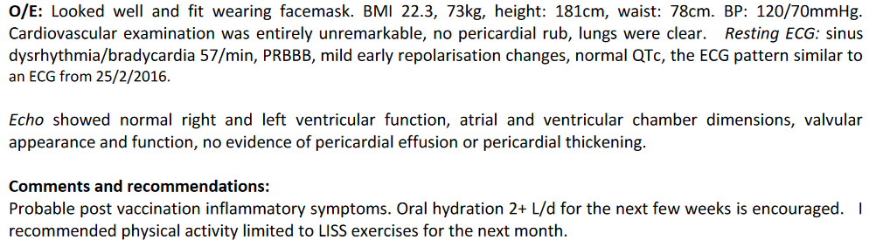
  - ECHO 30/9/21:
- 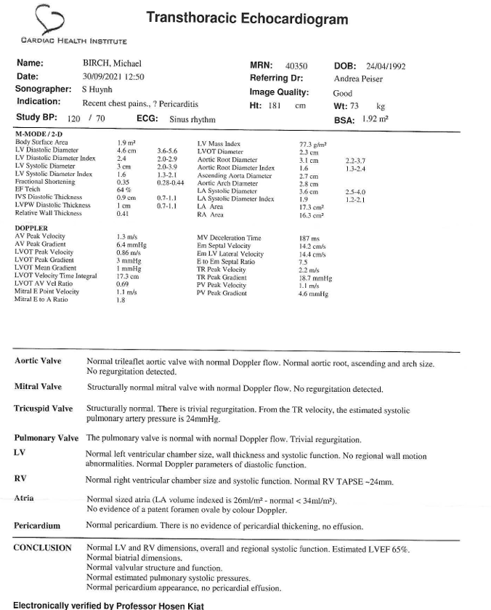
  - Some follow up appointments with cardiologist, however no changes in treatment or advice. Symptoms remained ISQ. Cardiologist handed me back to GP.
- Emergency Department 30 January 2022: stabbing chest pain (on and off for 2 days)
  - Troponin <3 ng/L, CXR NAD, ECG: NAD
  - Discharged without a diagnosis or changes to treatment.
- Cardiac MRI – no contrast - 6 April 2022
  - See attached report.
- Immunologist – Dr Karl Baumgart 16 May 2022
  - Refer to letter and blood tests.
  - No clear autoimmune condition, but some positive autoimmune markers in bloods.
  - Put on hydroxychloroquine.
- Emergency Department – WISE – 1 Oct 2024
  - Mild cold the week prior, then increased chest pain and palpitations.
  - Pain with breathing
  - Bloods: trop 2.78, D-dimer 0.27. CXR NAD.
  - Discharge letter:
  - “ Clinical assessment: Vitals: RR18, HR 60, BP 128/77, sats 100%, temp 36.6.
OE: speaking in full sentences, chest clear, HSDNNM, no pericaridial rub, calves soft non tender, no peripheral oedema.
ECG: sinus concave ST elevation laterally (V3-6_ new since last ECG done in June) with minimal ST elevation in most leads.
Impression: pericarditis, refer to cardiologist.
  - Holter monitor (results attached): “The predominant rhythm of the recording was sinus rhythm with intermittent first degree AV block. The minimum heart rate was 43 bpm (Wednesday, 2.October 2024 at 02:38), the maximum heart rate was 124 bpm (Wednesday, 2.October 2024 at 12:51). The average heart rate over the whole recording was 60 bpm. There were sporadic premature atrial contractions ob served. There were no premature ventricular contractions observed. There were no pauses >3 seconds detected. The patient reported symptoms of "flutters" at 07:31 on 02/10/24. This time correlated with sinus bradycardia. Conclusion: There were no significant arrhythmias detected from t his recording.”
- Cardiologist appointment 10 Oct 2024: Dr Mahnoor Mian
  - Refer to letter attached.
  - ECHO completed:
- 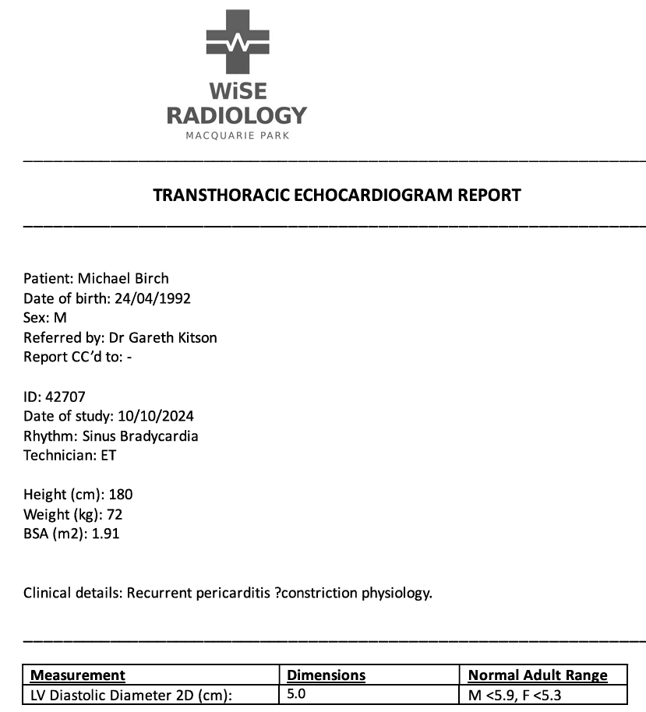
- 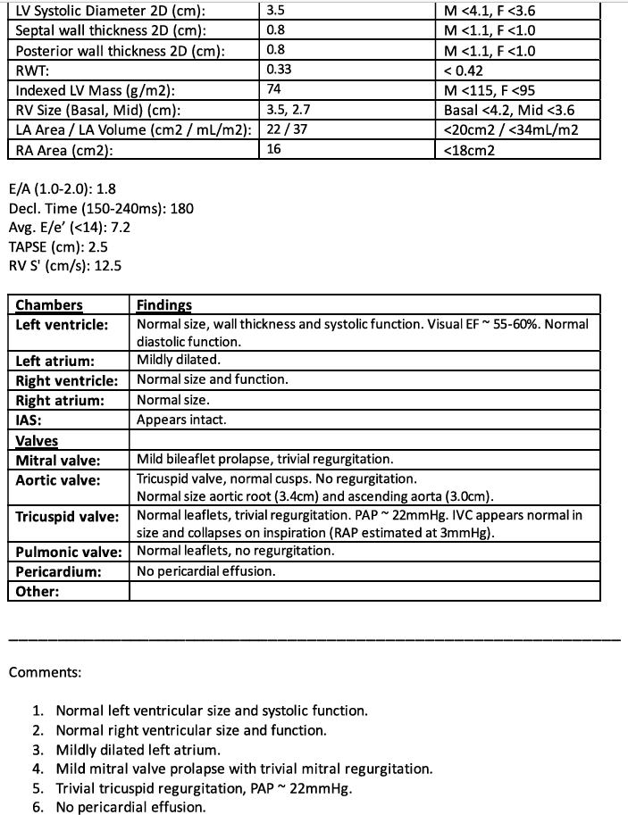
- Advice from cardiologist: continue with aspirin and colchicine, follow up in 6/12.

