Clinical Synopsis (Event > Clinical Synopsis)
Medical Officer Note - Deisy Labrador Moreno, 25 Oct 2024 21:27
Dear Doctor,
Thank you for your ongoing care of Clare Pitt. Clare is a 38-year-old female who was admitted under Obs and Gynae team on 23/10/2024 with the following issues:
# Pre-eclampsia:
- G3P0, GA 33+6 (admission day).
- Referred to the PAC with an elevated blood pressure of 150/80, completely asymptomatic.
- Was admitted for blood pressure monitoring and started on labetalol 200mg BD.
- Urine protein creatinine ratio 23/10/24: 44.
- Negative urine MCS.
- Obstetrics USS 24/10: The estimated foetal weight is 2478 gms. Fetal growth is on the 63 percentiles. Amniotic fluid volume normal. AFI 76mm. Cervix appears closed measuring 34mm in length. Placenta is posterior, lower margin 143mm from the internal os.
- Blood pressure controlled with labetalol, NIL PET symptoms during admission.

Tolerating oral diet and mobilising.
Cleared for discharge on 24/10 with the following plan:
1. To continue Labetalol 200mg BD.
2. Twice weekly Blood pressure checks. (PAC + MGP).
3. Weekly doppler scans + fortnightly growth scans.
4. Safety netted.

Please contact us should you have any questions on 6777 6777.
Kind regards,
Deisy Labrador
O&G RMO
Diagnostic Investigations (Event > Diagnostic Investigations)
Pathology Test Result (Event > Diagnostic Investigations > Pathology Test Result)
FINAL LGH - Urine culture ordered by Dr ALEXANDRA FRAIN on 23-Oct-2024
Recommended Future Action:
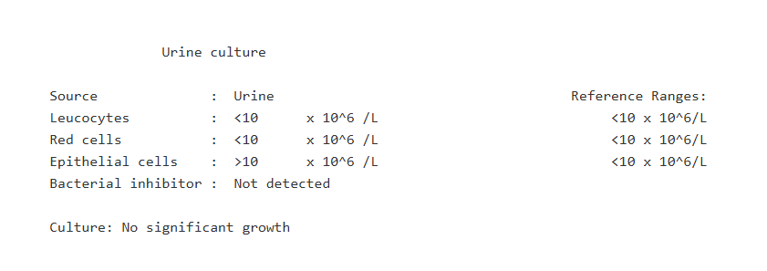

Pathology Test Result (Event > Diagnostic Investigations > Pathology Test Result)
FINAL LGH - Urine Prt/Crt Ratio ordered by Dr ALEXANDRA FRAIN on 23-Oct-2024
Recommended Future Action:

Date Collected : 23/10/24 09/10/24 25/09/24 12/09/24 Current
Time Collected : 12:20 N/S 10:40 N/S Reference
Episode : 24X062594 24X060077 24X057402 24X055130 Units Range
============== ========== ========== ========== ==========

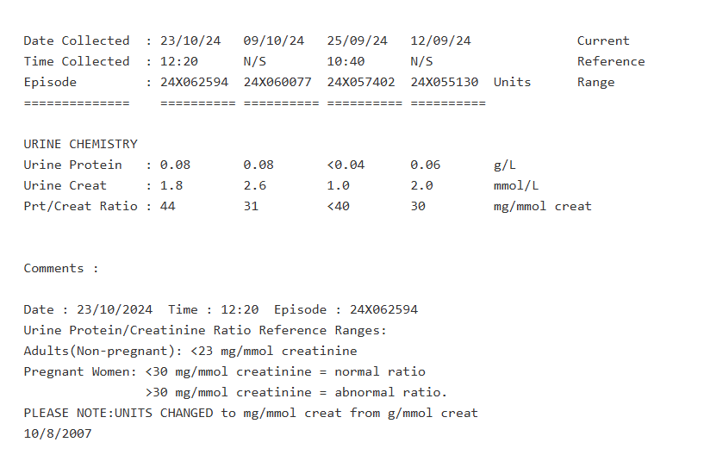Pathology Test Result (Event > Diagnostic Investigations > Pathology Test Result)
FINAL LGH - LFT (Serum) ordered by Dr ALEXANDRA FRAIN on 23-Oct-2024
Recommended Future Action:

Date Collected : 23/10/24 15/10/24 09/10/24 25/09/24 Current
Time Collected : 12:30 15:56 12:45 10:55 Reference
Episode : 24N119608 24N116374 24N113931 24N108233 Units Range
============== ========== ========== ========== ==========
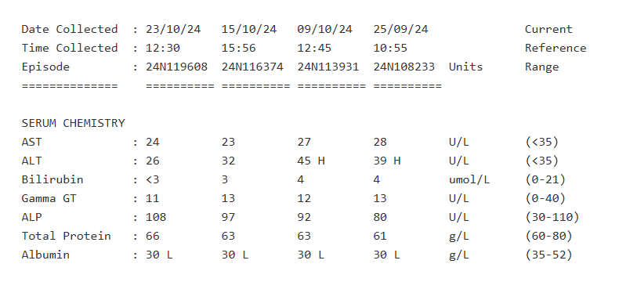
Pathology Test Result (Event > Diagnostic Investigations > Pathology Test Result)
FINAL LGH - Urate (Serum) ordered by Dr ALEXANDRA FRAIN on 23-Oct-2024
Recommended Future Action:

Date Collected : 23/10/24 15/10/24 09/10/24 25/09/24 Current
Time Collected : 12:30 15:56 12:45 10:55 Reference
Episode : 24N119608 24N116374 24N113931 24N108233 Units Range
============== ========== ========== ========== ==========

SERUM CHEMISTRY
Uric Acid : 0.25 0.22 0.24 0.28 mmol/L (0.14-0.34)
Pathology Test Result (Event > Diagnostic Investigations > Pathology Test Result)
FINAL LGH - Elect Urea Creat (Serum) ordered by Dr ALEXANDRA FRAIN on 23-Oct-2024
Recommended Future Action:

Date Collected : 23/10/24 15/10/24 09/10/24 25/09/24 Current
Time Collected : 12:30 15:56 12:45 10:55 Reference
Episode : 24N119608 24N116374 24N113931 24N108233 Units Range
============== ========== ========== ========== ==========
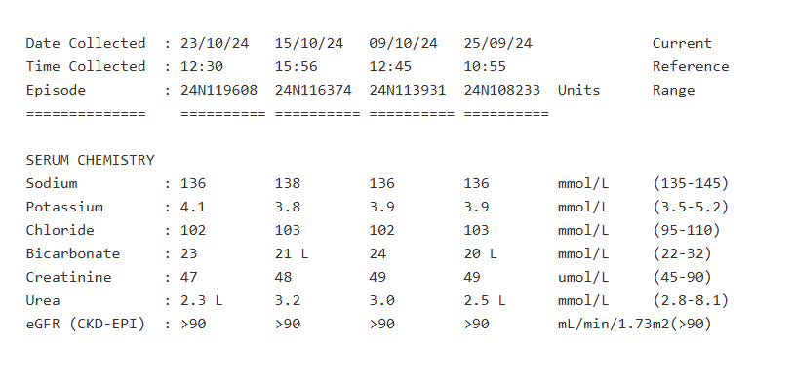

Comments :

Date : 23/10/2024 Time : 12:30 Episode : 24N119608
From 1 Feb 2016 eGFR is calculated using the CKD-EPI formula. For
details and limitations of use see MJA 197(4);222-223, 20 August 2012.
Pathology Test Result (Event > Diagnostic Investigations > Pathology Test Result)
FINAL LGH - Full Blood Count ordered by Dr ALEXANDRA FRAIN on 23-Oct-2024
Recommended Future Action:

Date Collected : 23/10/24 15/10/24 09/10/24 25/09/24 Current
Time Collected : 12:30 15:56 12:45 10:55 Reference
Episode : 24N119608 24N116374 24N113931 24N108233 Units Range
============== ========== ========== ========== ==========

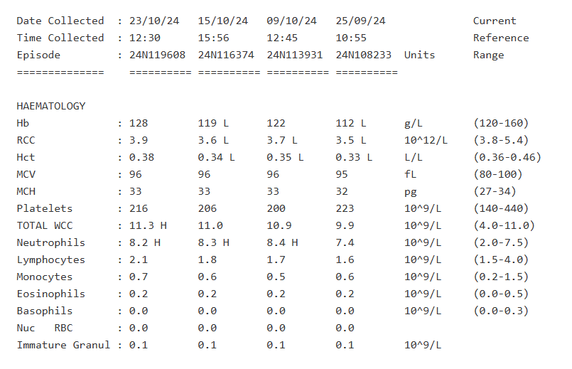Pathology Test Result (Event > Diagnostic Investigations > Pathology Test Result)
FINAL Obstetric Ultrasound >22 wks Subs ordered by Dr Toly Pavlov on 18-Oct-2024
Recommended Future Action:

OBSTETRIC ULTRASOUND

History: 38 year old. Uterine fibroid. Hypertension. Fetal well being.

Technique - Transabdominal scan

Comparison - none.

Findings:

Single live fetus. Cephalic presentation, longitudinal lie back to maternal
maternal right.

The fetal heart rate measures 148bpm.

The fetal biometry is as follows:

+-------+--------+-------------+
C2Xr4NnoP5Qru BPD C2Xr4NnoP5Qru 87mm C2Xr4NnoP5Qru 77 centile C2Xr4NnoP5Qru
+-------+--------+-------------+
C2Xr4NnoP5Qru HC C2Xr4NnoP5Qru 319mm C2Xr4NnoP5Qru 73 centile C2Xr4NnoP5Qru
+-------+--------+-------------+
C2Xr4NnoP5Qru AC C2Xr4NnoP5Qru 307mm C2Xr4NnoP5Qru 70centile C2Xr4NnoP5Qru
+-------+--------+-------------+
C2Xr4NnoP5Qru FL C2Xr4NnoP5Qru 66mm C2Xr4NnoP5Qru 63 centile C2Xr4NnoP5Qru
+-------+--------+-------------+

These measurements give an average estimated gestational age of 34 weeks 9
days.

The estimated fetal weight is 2478 gms.

Fetal growth is on the 63 percentile.

Amniotic fluid volume normal. AFI 76mm.

Cervix appears closed measuring 34mm in length.

Normal umbilical artery PI 0.76

Normal fetal movements. Normal breathing movements.

The placenta is situated posterior, is of normal morphology, lower margin
143mm from the internal os.

A full fetal morphology ultrasound was not performed. No abnormality however
is identified in the diaphragm, three-vessel cord, stomach, right kidney,
left kidney and bladder.

A left intramural fibroid of size 38 x 28 X 24 mm is noted.

CONCLUSION:-

Single live intrauterine fetus with biometry as mentioned.

Normal amniotic fluid volume.

Normal Doppler study.

(It is to be emphasised that ultrasound does not detect all foetal
abnormalities and a normal ultrasound study does not guarantee a perfect
baby - Joint position statement from ASUM, RACOG and RANZCR).

Reported by: Dr M. Arakkal, 24-Oct-2024 15:50

