INTELLIGENT, SCREENING

PANOS, CLAIRE 11 LINER ST WELLINGTON POINT QLD 4160
F 44 years 02/08/1979 INTELLIGENT, SCREENING INTELLIGENT, SCREENING

23/07/2024
23/07/2024 07:35 AM
23/07/2024 02:37 PM

00121687

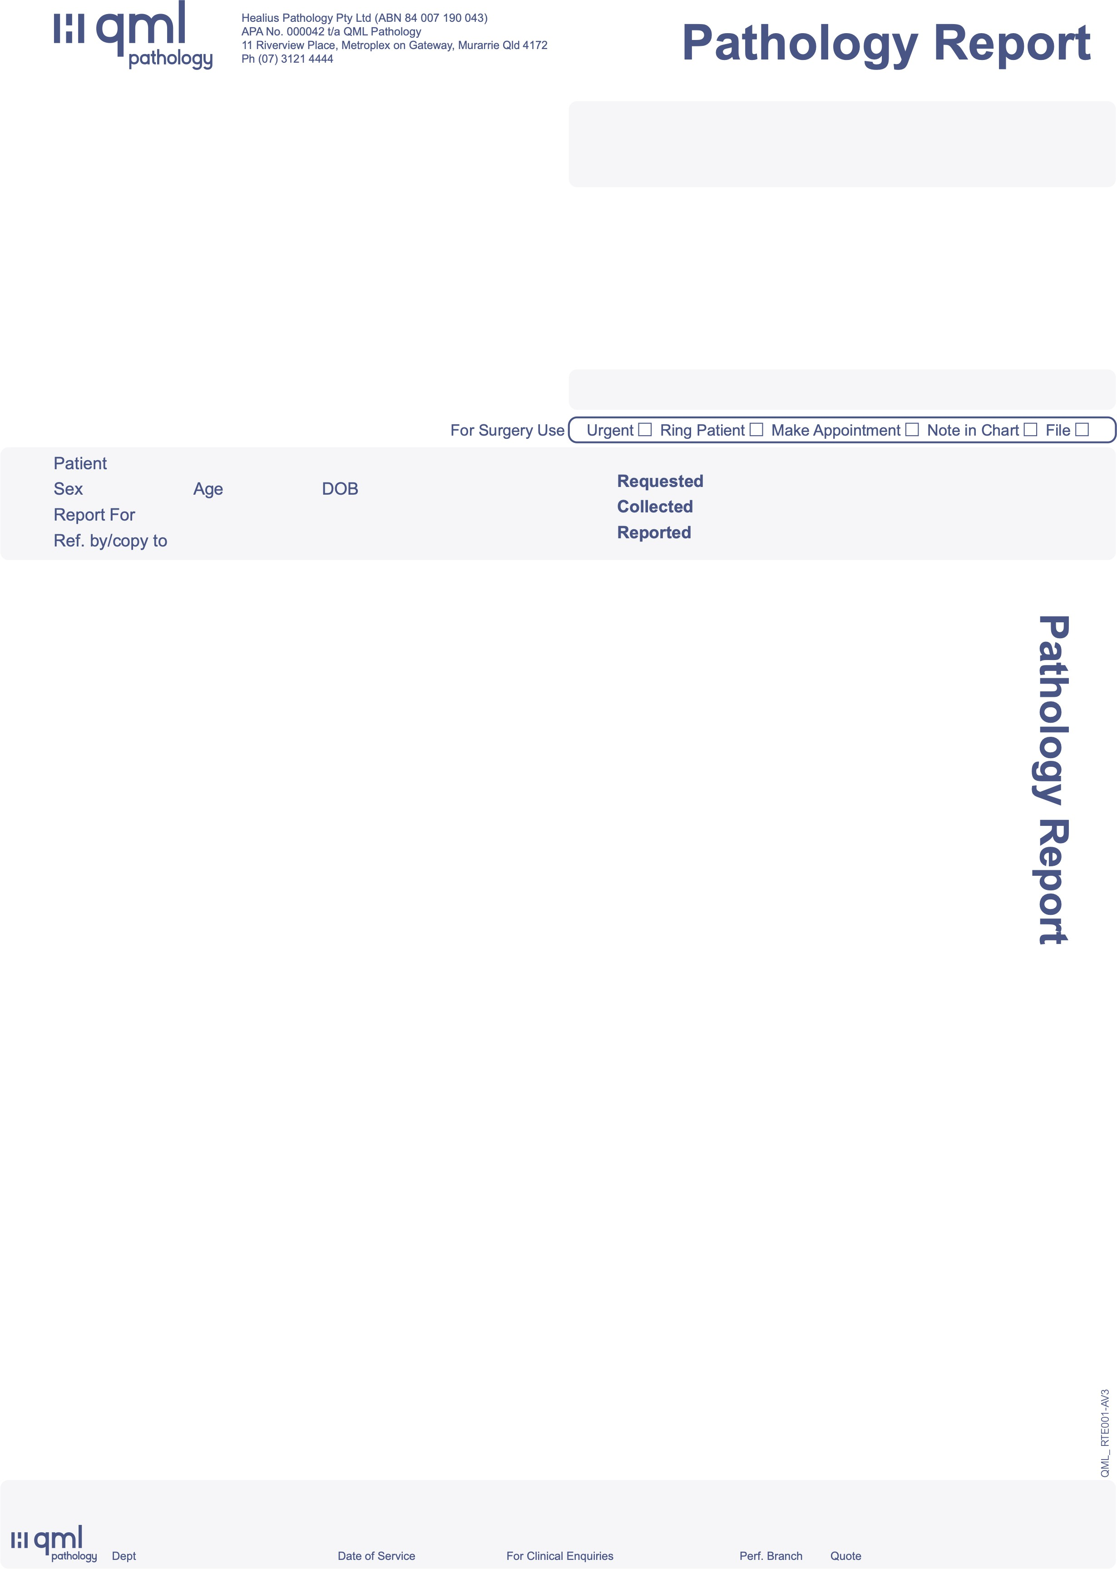
FULL BLOOD EXAMINATION
Haemoglobin |  |  | 129 | g/L |  | (115-160)
Red Cell Count |  |  | 4.3 | x10^12 | /L | (3.6-5.2)
Haematocrit |  |  | 0.39 |  |  | (0.33-0.46)
Mean Cell Volume |  |  | 92 | fL |  | (80-98)
Mean Cell Haemoglobin |  |  | 30 | pg |  | (27-35)
MCHC |  |  | 331 | g/L |  | (310-365)
Red Cell Dist. Width |  |  | 12.3 | % |  | (11.0-15.5)
Platelet Count |  |  | 208 | x10^9 | /L | (150-450)
Mean Platelet Volume |  |  | 11.0 | fL
White Cell Count |  |  | 5.2 | x10^9 | /L | (4.0-11.0)
Neutrophils | 58 | % | 3.0 | x10^9 | /L | (2.0-7.5)
Lymphocytes | 28 | % | 1.5 | x10^9 | /L | (1.1-4.0)
Monocytes | 6 | % | 0.3 | x10^9 | /L | (0.2-1.0)
Eosinophils | 7 | % | 0.36 | x10^9 | /L | (0.04-0.40)
Basophils | 1 | % | 0.05 | x10^9 | /L | (< 0.21)

Automated Comment:
As per ISLH guidelines - Film not reviewed. If a film review is truly indicated, contact the laboratory within 24 hours of collection.
Otherwise investigate any highlighted abnormalities as clinically appropriate.

All haematology parameters are within normal limits for age and sex.

1 of 5
24-74838659

INTELLIGENT, SCREENING

PANOS, CLAIRE 11 LINER ST WELLINGTON POINT QLD 4160
F 44 years 02/08/1979 INTELLIGENT, SCREENING INTELLIGENT, SCREENING

23/07/2024
23/07/2024 07:35 AM
23/07/2024 02:37 PM
00121687

CUMULATIVE FERTILITY HORMONES

Date 23/07/24
Time 07:35
Lab No 74838659

LH | 7 |  |  |  |  |  |  | IU/L
FSH | 7 |  |  |  |  |  |  | IU/L
E2 | 390 |  |  |  |  |  |  | pmol/L
Prog | 35 |  |  |  |  |  |  | nmol/L
Testo. | 0.7 |  |  |  |  |  |  | nmol/L |  | (0.4-2.1)
fTesto.c | 7 |  |  |  |  |  |  | pmol/L |  | (4-21)
SHBG | 73 |  |  |  |  |  |  | nmol/L |  | (18-114)
Ranges: | Follicular Phase |  | Midcycle Peak | Luteal Phase |  |  | Post-Menopausal
LH | 2 | - 12 | 10 - 130 | 1 | - | 17 | 15 |  | - 60
FSH | 1 | - 10 | 3 - 33 | 1 | - | 9 | 20 |  | - 140
Oestradiol | 70 | - 530 | 230 - 1310 | 200 | - | 790 | < |  | 120
Progesterone < 5 rising 20 - 110 < 3

74838659 This Progesterone level suggests Post-Ovulatory status.

CUMULATIVE SERUM VITAMIN D
Date | 23/07/24
Time | 07:35
Lab No | 74838659
Vitamin D3 | 56 | nmol/L (> 49)

74838659 We occasionally see evidence of functional vitamin deficiency and possibly accelerated bone loss with levels in the range of 50-70 nmol/L.

2 of 5
24-74838659

INTELLIGENT, SCREENING

PANOS, CLAIRE 11 LINER ST WELLINGTON POINT QLD 4160
F 44 years 02/08/1979 INTELLIGENT, SCREENING INTELLIGENT, SCREENING

CUMULATIVE LIPID RISK REPORT
Date 23/07/24
Time 07:35
Lab No 74838659
FASTING

23/07/2024
23/07/2024 07:35 AM
23/07/2024 02:37 PM

00121687

Target if HIGH RISK

Total Cholesterol 4.9 mmol/L (below 4.0)
Triglycerides 0.9 mmol/L (below 2.0)

CHOLESTEROL FRACTIONS
HDL 2.03 mmol/L (above 1.0)
LDL (calculated)* 2.46 mmol/L (below 2.5)
Non-HDL cholesterol* 2.87 mmol/L (below 3.3)
Total/HDL ratio** 2.4

* Secondary prevention LDL and non-HDL cholesterol targets are lower.
** The ratio is for use with the cardiovascular risk calculator.
Web-search: "Australian cardiovascular risk calculator"

74838659 Treatment is recommended if clinically indicated or if calculated risk exceeds 15% absolute risk of CVD events over 5 years.

NVDPA 2012 Target ranges refer to HIGH RISK PATIENTS.

As of 7/3/22 LDL will no longer be measured routinely. LDL results will be calculated, in accordance with National
harmonisation.

Serum Creatine Kinase (CK) 57 U/L (0-140)

3 of 5
24-74838659

INTELLIGENT, SCREENING

PANOS, CLAIRE 11 LINER ST WELLINGTON POINT QLD 4160
F 44 years 02/08/1979 INTELLIGENT, SCREENING INTELLIGENT, SCREENING

CUMULATIVE SERUM HIGH SENSITIVITY C-REACTIVE PROTEIN (CRP)
Date 23/07/24
Time 07:35
Lab No 74838659

23/07/2024
23/07/2024 07:35 AM
23/07/2024 02:37 PM

00121687

CRP 1.8 mg/L (0.0-6.0)

C-reactive protein (CRP) is a non-specific indicator of tissue damage. Common causes of markedly increased CRP include
infection, trauma, myocardial infarction, malignancy and inflammation.
In apparently healthy men and women who have an intermediate risk of cardiovascular disease, as assessed by major risk factors, CRP can identify a higher risk subgroup with CRP > 3 mg/L.
Range(mg/L) Risk Estimate
Up to 1.0 Low
1.0 to 3.0 Average
- to 10.0 High
Over 10.0 Assess for acute inflammation

In known, stable, coronary disease a CRP > 1 mg/L has shown increased risk.
Reference: Circulation 2003;107:499-511 & 2007;115:1528-1536

CUMULATIVE IRON STUDIES
Date 23/07/24
Time 07:35
Lab No 74838659
Ferritin 20 ug/L (25-290)

74838659

Comment:
Iron Deficiency. Correlate with full iron studies and FBC.

4 of 5
24-74838659

INTELLIGENT, SCREENING

PANOS, CLAIRE 11 LINER ST WELLINGTON POINT QLD 4160
F 44 years 02/08/1979 INTELLIGENT, SCREENING INTELLIGENT, SCREENING

CUMULATIVE SERUM BIOCHEMISTRY
Date 23/07/24
Time 07:35
Lab No 74838659

23/07/2024
23/07/2024 07:35 AM
23/07/2024 02:37 PM

00121687

FASTING FASTING
Sodium 136 mmol/L (137-147)
Potass. 4.2 mmol/L (3.5-5.0)
Chloride 104 mmol/L (96-109)
Bicarb 27 mmol/L (25-33)
An.Gap 9 mmol/L (4-17)
Gluc 5.1 mmol/L (3.0-6.0)
Urea 4.6 mmol/L (2.0-7.0)
Creat 64 umol/L (40-110)
eGFR > 90 mL/min (over 59)
Urate 0.27 mmol/L (0.14-0.35)
T.Bili 11 umol/L (2-20)
Alk.P 50 U/L (30-115)
GGT 10 U/L (0-45)
ALT 13 U/L (0-45)
AST 17 U/L (0-41)
LD 137 U/L (80-250)
Calcium 2.34 mmol/L (2.15-2.60)
Corr.Ca 2.30 mmol/L (2.15-2.60)
Phos 1.0 mmol/L (0.8-1.5)
T.Prot 69 g/L (60-82)
Alb 44 g/L (35-50)
Glob 25 g/L (20-40)
Chol 4.9 mmol/L (3.6-6.9)
Trig 0.9 mmol/L (0.3-2.2)
Lab No 74838659
Date 23/07/24

CUMULATIVE TRACE ELEMENTS
Date 23/07/24
Time 07:35
Lab No 74838659
Magnesium 0.8 mmol/L(0.7-1.1)

5 of 5
24-74838659

